

**Allied Packaging**

**Functional Requirement Document**

**Date: March 01, 2021**

**Version History**

|  |  |  |  |  |
| --- | --- | --- | --- | --- |
| **Version** | **Prepared On** | **Reviewed On** | **Reviewed By** | **Comments** |
| 1.0 | 03-01-2021 |  |  | First Draft |

**DOCUMENT APPROVAL PAGE**

Document Name:

I have carefully assessed this document and have determined that:

* + - * 1. ( _ ) The document is complete.
        2. (__) Pending the changes noted, the document is complete

Based on my authority and judgment, I acknowledge the effort as needed and authorize work to proceed.

Concerned Persons:

1. Chad / Engagement Director - Softweb

Signature: _____________________________ Date:

1. Vaikunth Parmar/ Project Manager - Softweb

Signature: _____________________________ Date:

1. Himanshu Patel / Business Analyst - Softweb

Signature: _____________________________ Date:

Contents

1. PROJECT SUMMARY 6

1.1. Purpose 6

1.2. Project Objective 6

1.3. System Overview 6

1.4. User Roles 8

1.5. General Assumptions 8

2. Web portal 9

2.1. Login 9

2.2. Forgot Password 11

2.3. Reset Password 13

2.4. Dashboard 15

2.5. Report Details 16

2.6. Users Management 16

2.6.1. Users List 16

2.6.2. Add/Edit User 21

2.7. Facility Management 23

2.7.1. Facility List 23

2.7.2. Add/Edit Facility 27

2.7.3. Add/Edit Shift 33

2.7.4. Add/Edit Off Time 35

2.8. Machine Management 37

2.8.1. Machine List 37

2.8.2. Add/Edit Machine 41

2.8.3. Machine Detail 44

2.8.4. Machine Configuration 47

2.9. Film Management 54

2.9.1. Film List 54

2.9.2. Add/Edit Film 57

2.9.3. Film Configuration 60

2.10. Recipe Management 65

2.10.1. Recipe List 66

2.10.2. Add/Edit Recipe 69

2.10.3. Recipe Configuration 72

2.11. Web Break 80

2.12. Alerts 83

2.13. My Profile 85

2.14. Verification 88

# PROJECT SUMMARY

## Purpose

The purpose of this document is to present detailed functional requirements for Allied Packaging. It facilitates various stakeholders to understand detailed functionalities of the system. It includes:

* Overall Web interface Functionality
* Basic Screen Design outlining the functionalities

This document outlines the functionalities and the processes visually to provide a clearer understanding for the stakeholders & development team and eliminate ambiguity within the requirements.

## Project Objective

Allied packaging provides their service in to packaging industry. They are looking for an IoT solution for their corporate users so, users can easily access the machine data from anywhere.

Avnet proposes to implement a custom solution for Allied Packaging. Using this proposed solution Corporate Admin will be able to manage users, facilities, machines, shift, and off time. User will be able to perform configuration of the machine, recipe and film. This solution showcase insight of the various parameters for each machine. The solution will also create alerts based on the events codes received from the Allied machines.

This custom solution will be built on top of Avnet IoTConnect platform. This document contains the scope of work.

## System Overview

Major modules of the system are identified as:

**Web Application**

* Dashboard - Essentially the control panel for the website where admin can have a quick view over the number of products, clients and quotations in the system.
* Users Management - Ability for the Admin user to manage the registered users in the system. Admin can provide access permission to the users.
* Facility Management - Ability to create and manage the facility, facility details along with the shift and off time.
* Machine Management - Ability for the Admin user to create and machine from this section. Admin can configure machine parameters from this module.
* Film Management - Ability for the Admin user to manage the film and configure film using this module.
* Recipe Management - Ability for the Admin user to manage the Recipe and configure recipe using this module.

## User Roles

|  |  |  |
| --- | --- | --- |
| **Application** | **User** | **Roles** |
| **Web Panel** | **Administrator User** | **Administrator user will be able to manage users, facilities, machine, film and recipe.** |

## General Assumptions

* Solution will support English language only.
* Web application will work in online mode only.
* We have considered one way communication for this solution. (Machine to Cloud)
* Below mentioned User Interface is for the Corporate users.
* Proposed solution will be a stand-alone solution. We have not considered integration with any other Applications, APIs or Databases etc.
* We haven’t considered any specific compliance requirements into the scope.
* We haven’t considered sending any commands to the devices.
* Proposed solution only consists of web portal. Mobile application has not been considered into the current scope.
* Allied Team will provide Twilio/SMS API account details to be used for Text alerts.
* We assume that Allied hardware team will be responsible to send the data to IoTConnect.

# Web portal



## Login

User will be able to login to the system with the valid credentials in order to access web portal as shown in below image.

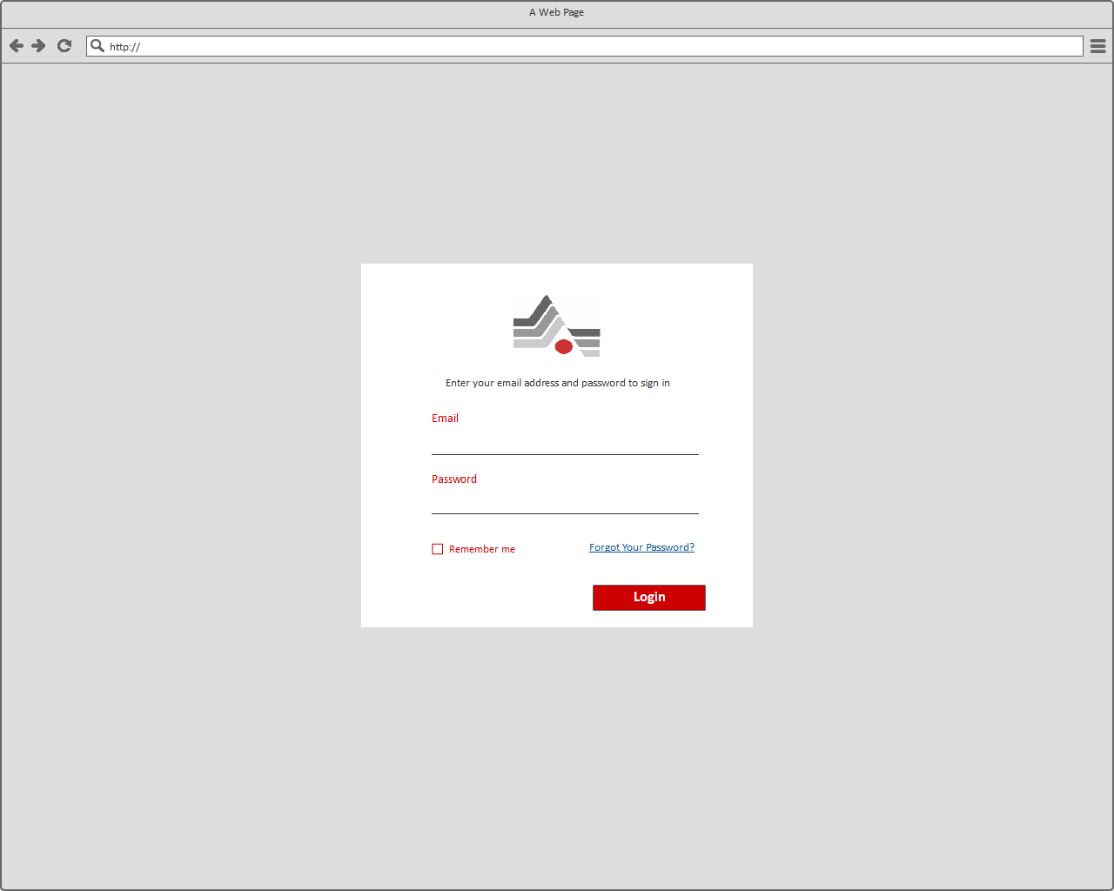

***[Login]***

Description

User has to provide valid credentials to login to the system. Below are the input parameters with their field type.

|  |  |  |  |  |
| --- | --- | --- | --- | --- |
| # | Field Name | Type | Mandatory (Y/N/NA) | Description |
| 1 | Email | Textbox | Y | This field will allow user to enter Email in the textbox provided.  **Notes**:   1. It should be **registered** with the system else message will be displayed that ‘*Please enter valid Email id*’ 2. Email id must have valid prefix and an email domain, both in acceptable formats, or else message will be displayed ‘*Please enter valid Email id*’ |
| 2 | Password | Textbox | Y | This field will allow user to enter password – It will be masked.  **Notes**:   1. User should enter valid password else message will be displayed that ‘*Please enter valid Email ID or Password*’ 2. The Password must be of 8 characters long. If any password less than this is entered then the system will show the message ‘*Please enter valid password’* |
| 3 | Forgot Your Password? | Link | NA | Clicking on this link should navigate the users to the page where user should be able to provide his/her email address to retrieve the password. |
| 4 | Login | Button | NA | System will validate information entered by the user and on successful validation user will be redirected to Home Page else it will display appropriate validation message. |
| 5 | Remember Me | Checkbox | NA | By checking on box, application will remember the credentials of the user and user does not have to enter the credentials again for accessing the User panel. |

## Forgot Password

This page will allow the users to reset their forgotten password by providing registered email address. Upon successful verification of the email, system should send an email containing a link to the password reset page.

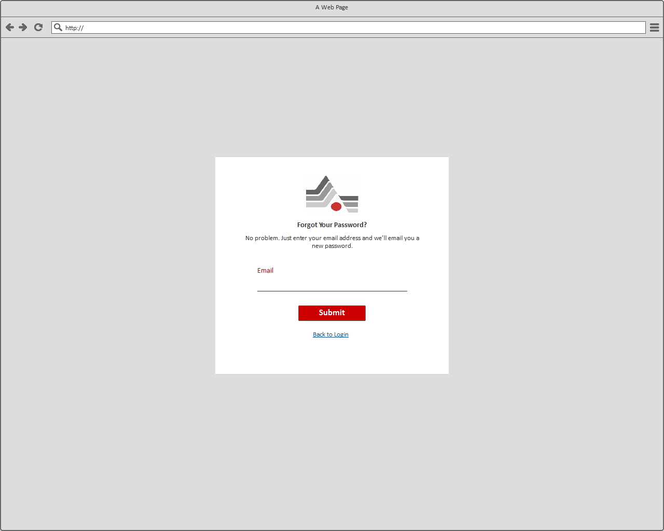

***[Forgot Password]***

Description

As shown in above page, users should enter the registered email address in order to receive the password reset link.

|  |  |  |  |  |
| --- | --- | --- | --- | --- |
| # | Field Name | Type | Mandatory (Y/N/NA) | Description |
| 1 | Email | Textbox | Y | User will be able to enter valid Email Id.  **Notes**:   1. It should be **registered** with the system else message will be displayed that ‘*Please enter valid Email id*’ 2. Email id must have valid prefix and an email domain, both in acceptable formats, or else message will be displayed ‘*Please enter valid Email id*’ |
| 2 | Submit | Button | NA | On submitting system will display the message that ‘Email has been sent to your registered email Id, please follow the steps mentioned in the email to create a new password.’  **Note**:   1. User will receive an email with the link from where he/she will be able to create a new password. |
| 3 | Back to Login | Link | NA | Clicking on it, user will be redirected on Login page. |

## Reset Password

User will be able to reset the password from the page by entering the following details.

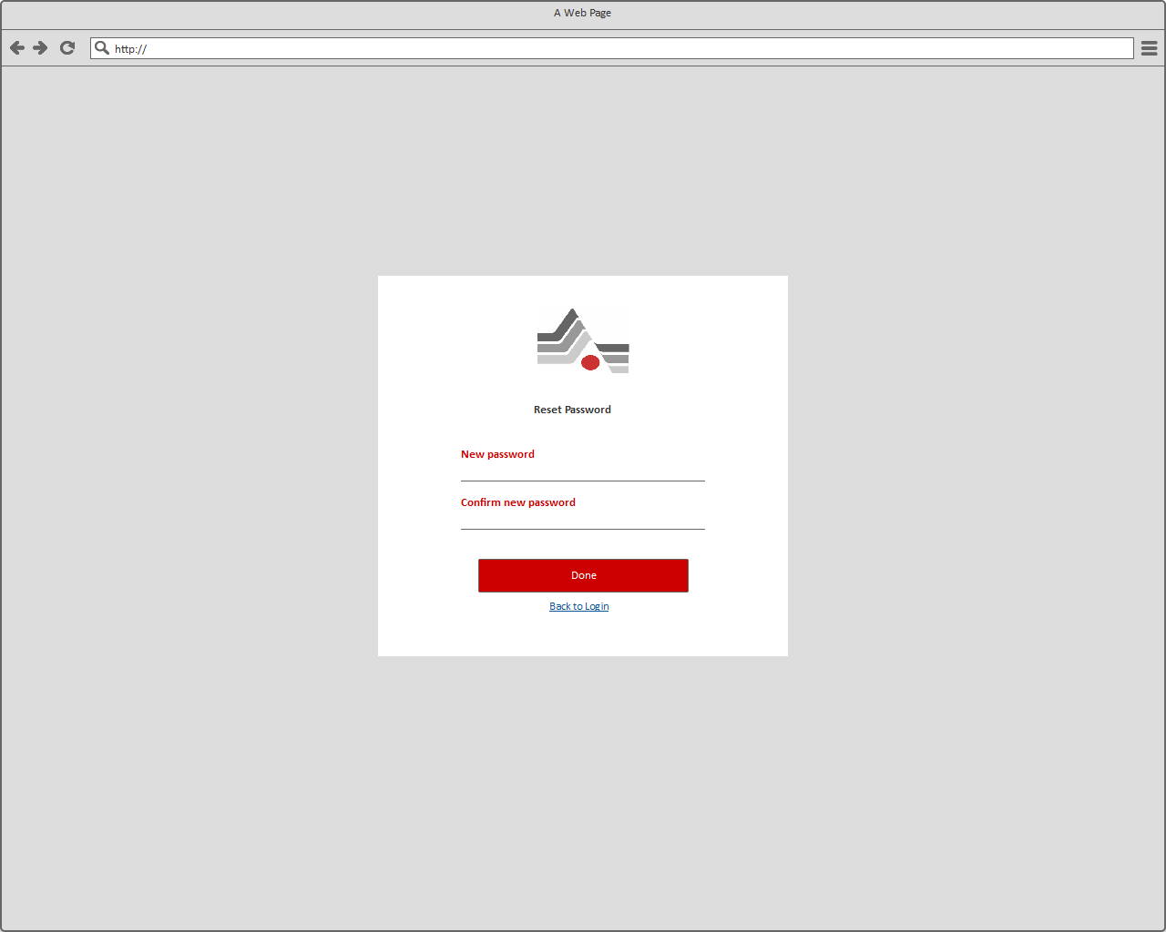

***[Reset Password]***

Description

As shown in above page, users should enter new password and Confirm new password in order to create/reset their password.

|  |  |  |  |  |
| --- | --- | --- | --- | --- |
| # | Field Name | Type | Mandatory (Y/N/NA) | Description |
| 1 | New password | Textbox | Y | This field will allow user to enter new password – It will be masked.  **Notes:**   1. The password should be a combination of alphabets, numbers and special characters. It should be minimum 8 characters long and contain at least 1 upper case character, 1 number and 1 special character. 2. In case password entered by user doesn’t meet password strength requirements then warning message should be displayed. |
| 2 | Confirm new password | Textbox | Y | This field will allow user to re-enter new password – It will be masked.  **Notes:**   1. User shall enter the same passwords in both the fields. If the passwords get mismatched, then appropriate validation message will be displayed on the page. |
| 3 | Done | Button | NA | System will save the passwords entered by the user and will redirect User to Login Page for accessing the panel. |
| 4 | Back to Login | Link | NA | User will be redirected back to the login page. |

## Dashboard

User will be redirected to the Dashboard after successful login. User will be able to view below items on Dashboard.

* Menu Navigation (It will be displayed in all the pages)
* Filter Options are as:
  + View Last Wrap Cycle
  + View Current Shift
  + View Previous Shift
  + View Last 30 Days
  + View Last 90 Days
  + Select Custom range – Selecting this option, it allows to enter custom date range, pallet range and shift
* It shows following insights:
  + Pre-Stretch (in %)
  + Total Applied Stretch (in %)
  + Number of Wraps
  + Web Breaks
  + Film Weight (Ounces)
  + Film Cost (in $)
  + Cycle Time (hrs.)
  + Alert List

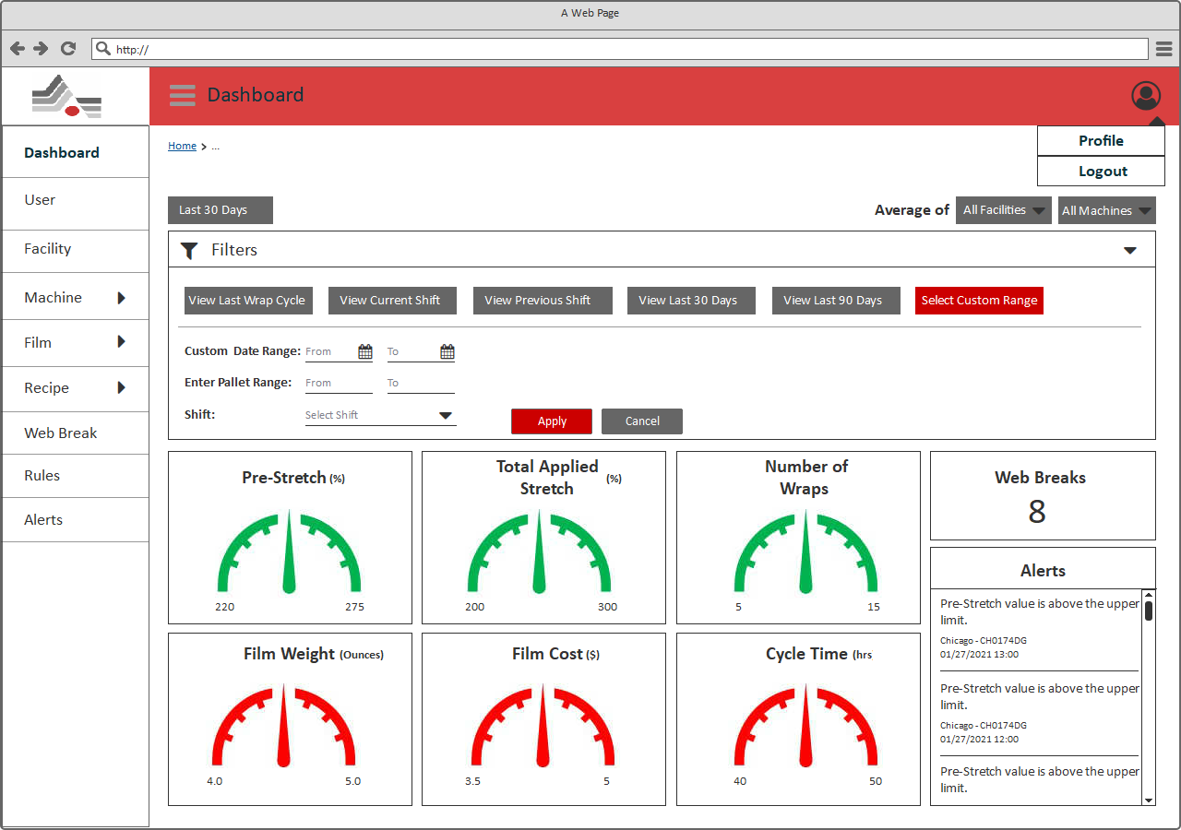

***[Dashboard]***

## Report Details

This page can be accessible by clicking on any report. It shows detail view of the selected report.

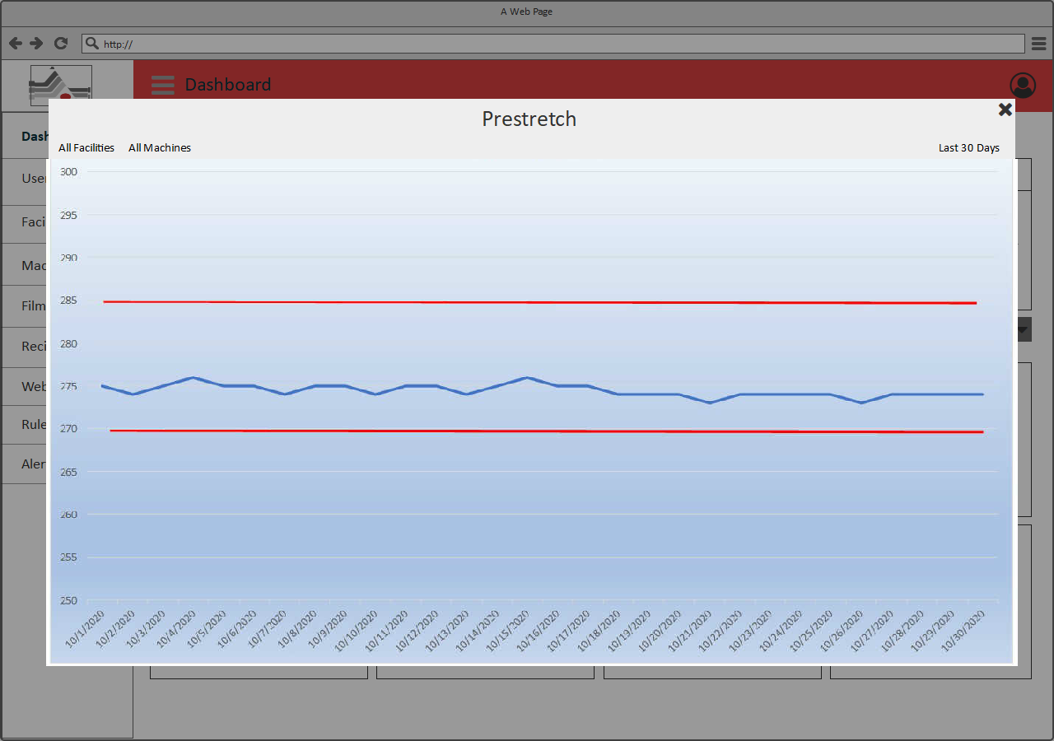

***[Report Detail View]***

## Users Management

By clicking on “User” from the menu navigation, it redirects user to this page. It allows to manage all the users from this section. It includes:

* View list of Users (With Edit and Delete options)
* Add User details

## Users List

As shown in below “Users List” page, Admin will be able to view list of User with its details.

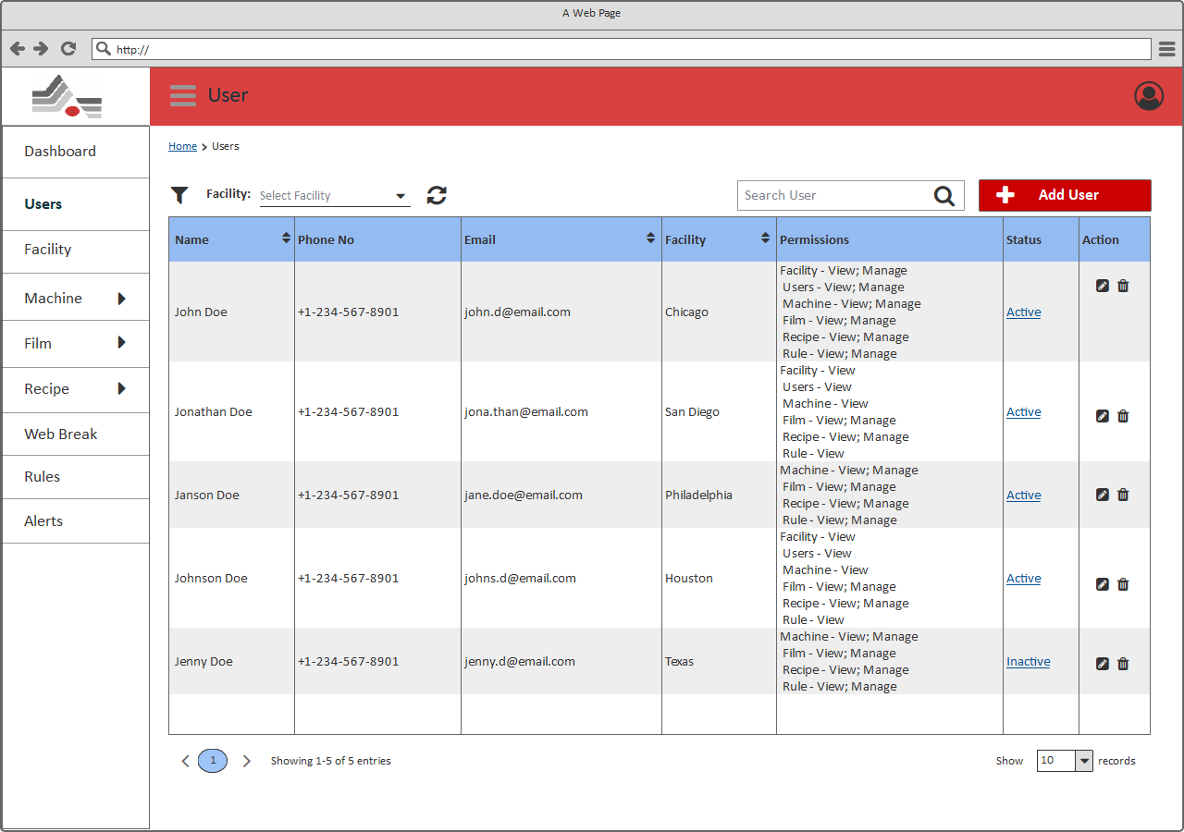

***[Users List]***

Description

As shown in above page, User should be able to view the list of users along with edit, delete options.

|  |  |  |  |  |
| --- | --- | --- | --- | --- |
| # | Field Name | Type | Mandatory (Y/N/NA) | Description |
| Page Header: User can view the title of the page (User) and should be able to perform below mentioned actions. | | | | |
| 1 | Breadcrumb | Link | NA | User will be able to view the breadcrumb/navigation of current page. Using the breadcrumb, user will be able to navigate to the previous navigations.  Depending on the module from where the user is accessing this page, information in the breadcrumb will be generated dynamically. |
| 2 | Search | Textbox | NA | User will be able to search any user through keyword search available on the page.  **Note**:   1. Search should be performed on all the existing users and if the result comprises multiple pages, then user should be able to access the next/previous result pages through pagination option. 2. User should get a message “***No results found***” when no record found as per the keyword. |
| 3 | Filter | Dropdown | NA | User will be able to select “Facility” from the dropdown options. It allows to select single option from the dropdown. After selecting any option filter activity should be initiated. It displays list of users fall underneath selected facility. |
| 4 | Add User | Button | NA | User will be redirected to the Add new user page. |
| View list of users: Users should be able to view a list of all the existing users with below mentioned details. If no user is added into the system, page should display a message “*No user exists*”. | | | | |
| 5 | Name | Label | NA | User will be able to view name of the existing users.  **Note**:   1. User should be able to sort the users alphabetically through the sort icon available with Name title in the grid. |
| 6 | Phone | Label | NA | User will be able to view phone number of the existing users. |
| 7 | Email | Label | NA | User will be able to view registered email id of the existing users.  **Note**:   1. User should be able to sort the email alphabetically through the sort icon available with Email title in the grid. |
| 8 | Facility | Label | NA | User will be able to view associated facilities of the existing users.  **Note**:  User should be able to sort the facility alphabetically through the sort icon available with Facility title in the grid. |
| 9 | Permissions | Label | NA | User will be able to view assigned permissions of the existing users. |
| 10 | Status | Link | NA | User will be able to view the current status of the user.  User can active or inactive the users from the system.  Clicking on the link, User will see the pop-up with the message “Are you sure you want to active/inactive the user?”  Clicking on yes, the user will be activated/inactivated. Clicking on cancel, User will be redirected back to the User’s listing page. |
| 11 | Action | Icons | NA | User will be able to edit any existing users by clicking on “” icon available with each User. It will redirect User to the Add/Edit User Page; with prefilled values of the selected User; where information can be added/modified.  User will be able to click on “” icon available with each user to delete that particular user.  **Note:**  1. By clicking on delete icon available with each record in the User’s list; it will display a pop-up with confirmation message such as ***“Are you sure you want to delete this User?”***  -- If User selects yes then the selected user will be deleted else no action will be performed. |
| 12 | Pagination | Buttons | NA | User will be able to access the other users through the pagination available on the page.  Clicking on the page numbers will navigate the User to that page which contains the Users. |
| 13 | Page Size | Dropdown | NA | User can also manage the number of items to be displayed into the list through a page size combo box with options10/25/50/100 items in a list.  **Note**: By default, only 10 Records will be displayed. |

## Add/Edit User

As shown in below “Add /Edit User” page, Admin will be able to add/edit new user. This page can be accessible form the “User List” page, clicking on “Add User” will redirect on this page.

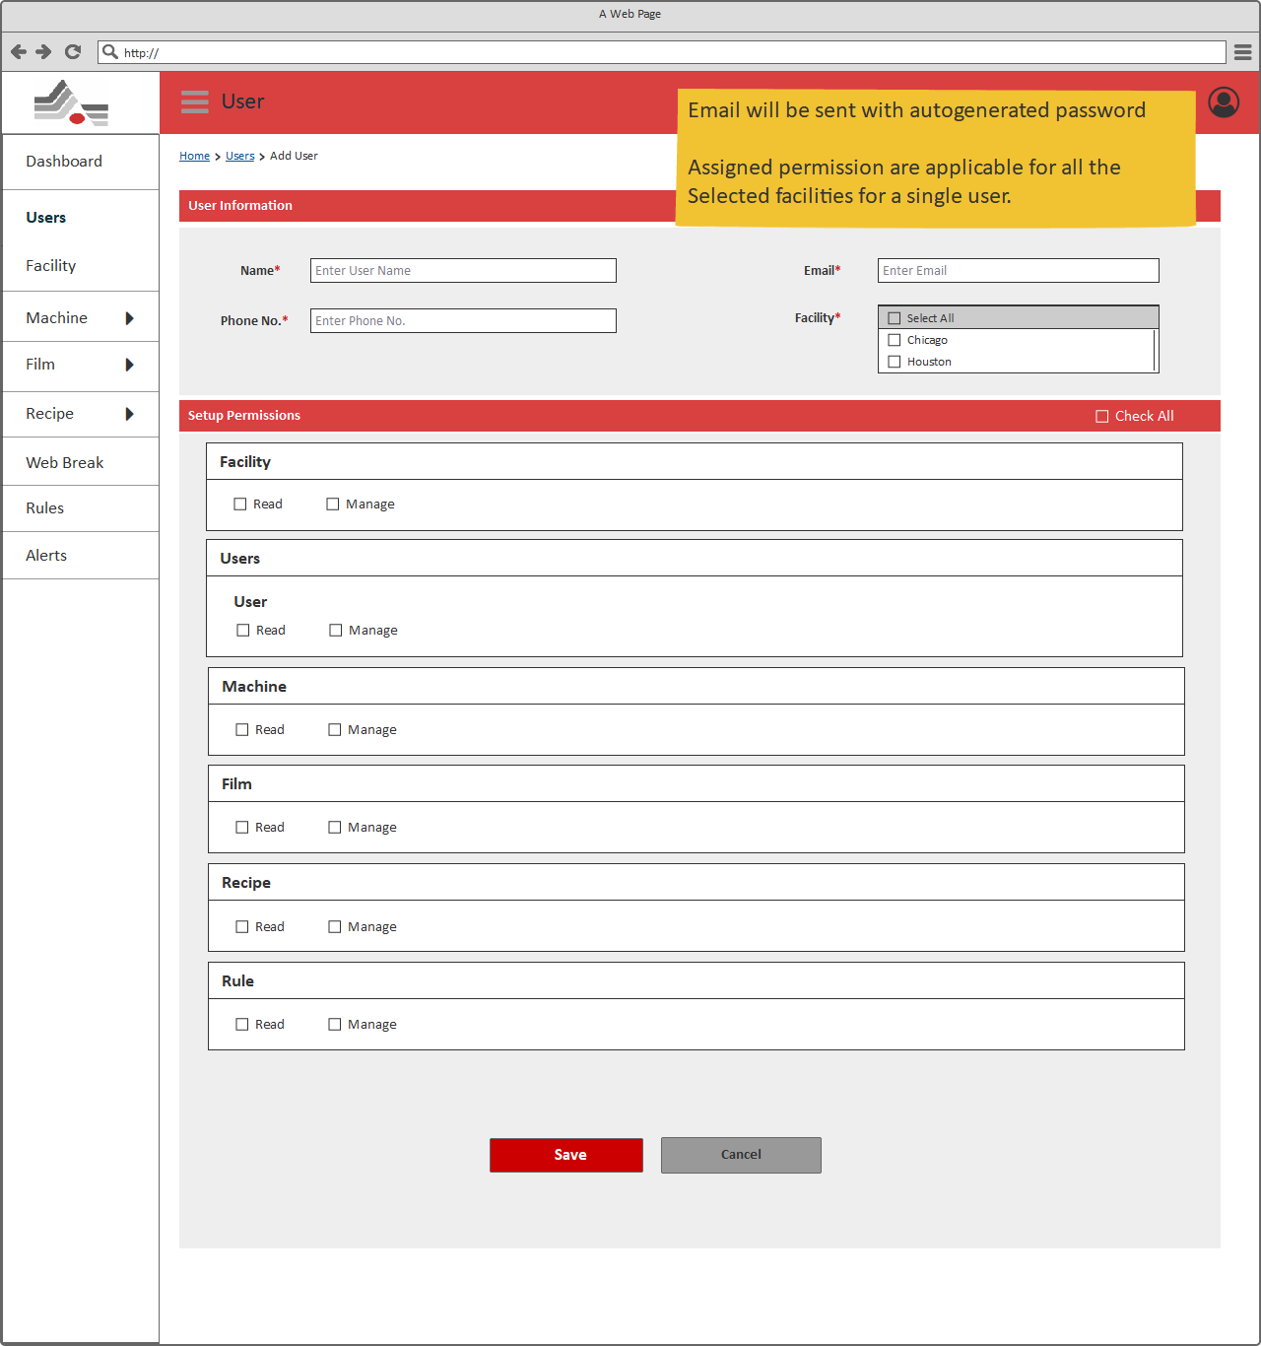

***[Add User]***

Description

As shown in above page, user should be able to add/edit user’s information through this page.

|  |  |  |  |  |
| --- | --- | --- | --- | --- |
| # | Field Name | Type | Mandatory (Y/N/NA) | Description |
| Page Header: User can view the title of the page (User) and should be able to perform below mentioned actions. | | | | |
| 1 | Breadcrumb | Link | NA | User will be able to view the breadcrumb/navigation of current page. Using the breadcrumb, user will be able to navigate to the previous navigations.  Depending on the module from where the user is accessing this page, information in the breadcrumb will be generated dynamically. |
| 2 | Name | Textbox | Y  ‘Enter User Name’ | User will be able to add/edit name of the user.  **Note**:   1. Input of this field should be alphabets only. If user has entered numbers or special characters then it should display an error message, **“Please enter valid Name”** along with information of valid input type.   Edit: This field will contain the prefilled value based on the selected User from the User listing page. |
| 3 | Email | Textbox | Y  ‘Enter Email’ | User will be able to add the email of the user.  **Notes**:   1. Email address of the user should be **unique** throughout the system so that user should not be able to add two users having same email address in the system**.** In case ofduplicate email address**,** it should display message that “***Email address already exists***”. 2. User should enter the email address in proper format else display an error message “**Invalid email address**”.   Edit: This field will contain the prefilled value based on the selected User from the User listing page. It will not be editable. |
| 4 | Phone no | Textbox | Y  ‘Enter Phone No’ | User will be able to add/edit the phone number of the user.  **Notes:**   1. Phone number textbox should only accept numbers. It should contain standard template of “XXX-XXX-XXXX” 2. Contact number should not exceed more than 10 numbers. If less than 10 numbers are added into the field, then the numbers colour will be turned red and the message will be displayed “Enter valid contact number’   Edit: This field will contain the prefilled value based on the selected User from the User listing page. |
| 5 | Facility | Multi Select | Y  ‘Select Facility’ | User will be able to select/update facility from the Dropdown list.  User has to assign one facility to the user.  Edit: This field will contain the prefilled value based on the selected User from the User listing page. |
| 6 | Setup Permission | Multi Select | Y  ‘Select Permission’ | User will be able to select/update permissions of the user.  User has to assign one permission to the user.  Edit: This field will contain the prefilled value based on the selected User from the User listing page. |
| 7 | Save | Button | NA | Clicking on Save will redirect to the Users listing page |
| 8 | Cancel | Button | NA | Clicking on Cancel will redirect to the Users listing page |

## Facility Management

It allows to manage all facility, shift and leaves from this section. This page can be accessible, by clicking on “Facility” menu from the left side navigation menu.

## Facility List

As shown in below “Facility List” page, Admin will be able to view list of Facility with its details.

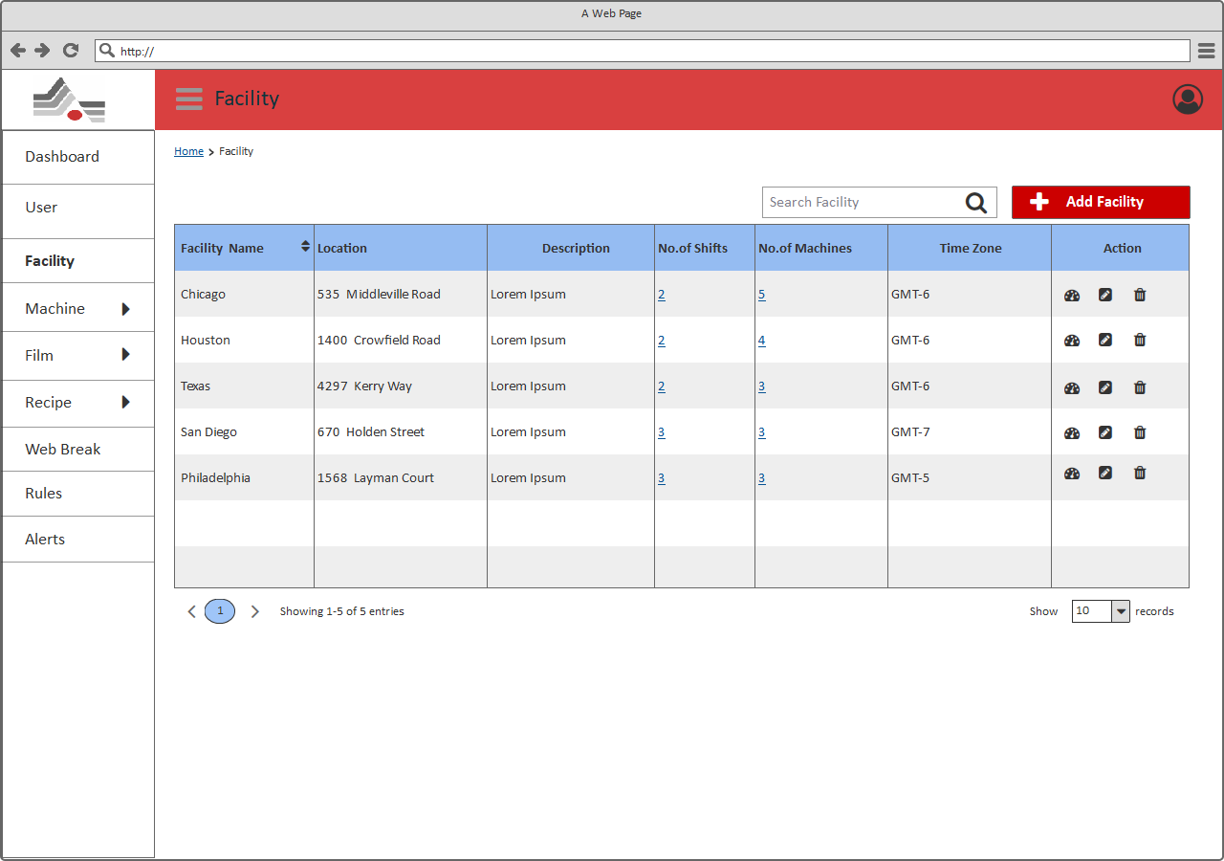

***[Facility List]***

Description

As shown in above page, User should be able to view the list of facilities along with edit, delete and view dashboard options.

|  |  |  |  |  |
| --- | --- | --- | --- | --- |
| # | Field Name | Type | Mandatory (Y/N/NA) | Description |
| Page Header: User can view the title of the page (Facility) and should be able to perform below mentioned actions. | | | | |
| 1 | Breadcrumb | Link | NA | User will be able to view the breadcrumb/navigation of current page. Using the breadcrumb, user will be able to navigate to the previous navigations.  Depending on the module from where the user is accessing this page, information in the breadcrumb will be generated dynamically. |
| 2 | Search | Textbox | NA | User will be able to search any facility through keyword search available on the page.  **Note**:   1. Search should be performed on all the existing facilities and if the result comprises multiple pages, then user should be able to access the next/previous result pages through pagination option. 2. User should get a message “***No results found***” when no record found as per the keyword. |
| 3 | Add Facility | Button | NA | User will be redirected to the Add new facility page. |
| View list of Facilities: Users should be able to view a list of all the existing facilities with below mentioned details. If no facility is added into the system, page should display a message “*No facility exists*”. | | | | |
| 4 | Facility Name | Label | NA | User will be able to view name of the existing facility.  **Note**:   1. User should be able to sort the facility alphabetically through the sort icon available with Facility Name title in the grid. |
| 5 | Location | Label | NA | User will be able to view location of the existing facility. |
| 6 | Description | Label | NA | User will be able to view description of the existing facility. |
| 7 | No. of Shift | Label | NA | User will be able to view counts of the no. of shifts of the existing facility. |
| 8 | No. of Machines | Label | NA | User will be able to view counts of the no. of machines of the existing facility. |
| 9 | Time Zone | Label | NA | User will be able to view time zone of the existing facility. |
| 10 | Action | Icons | NA | User will be able to click on “” icon available with each facility to view Dashboard for that particular facility.  User will be able to edit any existing facility by clicking on “” icon available with each facility. It will redirect User to the Add/Edit Facility Page; with prefilled values of the selected Facility; where information can be added/modified.  User will be able to click on “” icon available with each facility to delete that particular facility.  **Note:**  1. By clicking on delete icon available with each record in the Facility’s list; it will display a pop-up with confirmation message such as ***“Are you sure you want to delete this Facility?”***  -- If User selects yes then the selected facility will be deleted else no action will be performed. |
| 11 | Pagination | Buttons | NA | User will be able to access the other facilities through the pagination available on the page.  Clicking on the page numbers will navigate the User to that page which contains the facilities. |
| 12 | Page Size | Dropdown | NA | User can also manage the number of items to be displayed into the list through a page size combo box with options10/25/50/100 items in a list.  **Note**: By default, only 10 Records will be displayed. |

## Add/Edit Facility

As shown in below “Add /Edit Facility” page, Admin will be able to add/edit new facility. This page can be accessible from the “Facility List” page, clicking on “Add Facility” will redirect on this page.

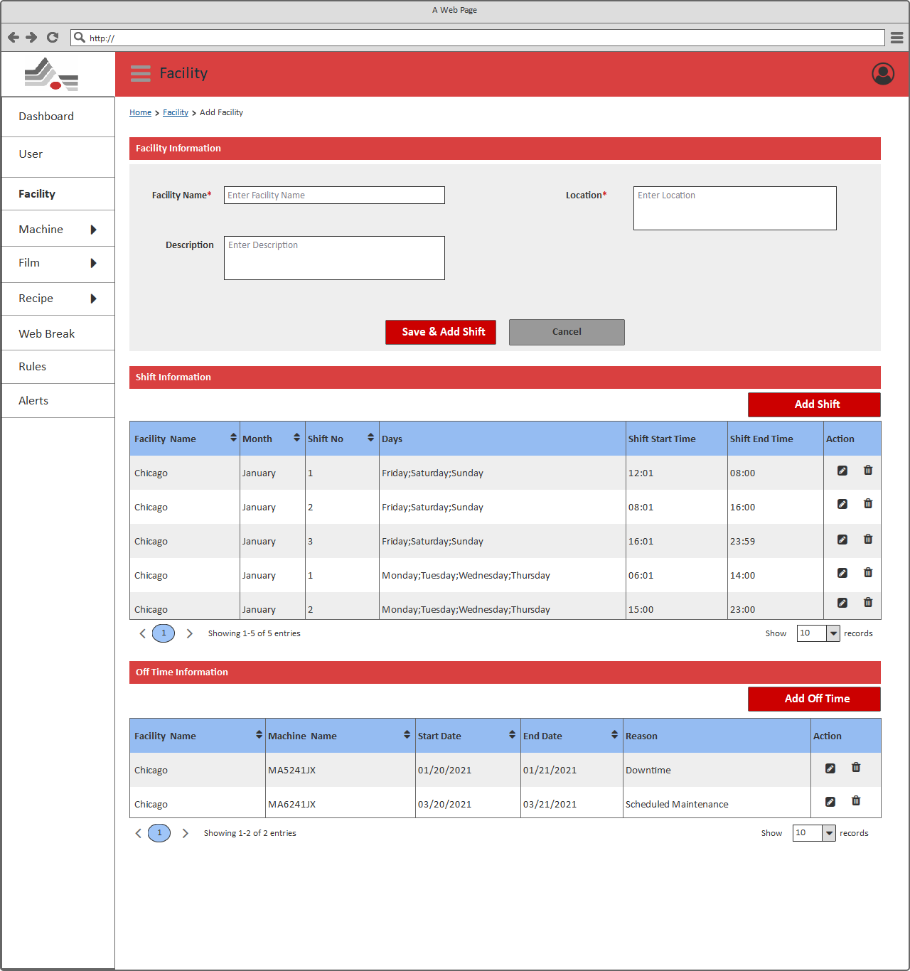

***[Add Facility]***

Description

As shown in above page, user should be able to add/edit facility’s information through this page.

|  |  |  |  |  |
| --- | --- | --- | --- | --- |
| # | Field Name | Type | Mandatory (Y/N/NA) | Description |
| Page Header: User can view the title of the page (Facility) and should be able to perform below mentioned actions. | | | | |
| 1 | Breadcrumb | Link | NA | User will be able to view the breadcrumb/navigation of current page. Using the breadcrumb, user will be able to navigate to the previous navigations.  Depending on the module from where the user is accessing this page, information in the breadcrumb will be generated dynamically. |
| 2 | Facility Name | Textbox | Y  ‘Enter Facility Name’ | User will be able to add/edit name of the facility.  **Note**:   1. Input of this field should be alphanumeric only. If user has entered any special characters then it should display an error message, **“Please enter valid Facility Name”** along with information of valid input type.   Edit: This field will contain the prefilled value based on the selected Facility from the Facility listing page. |
| 3 | Location | Text area | Y  ‘Enter Location’ | User will be able to add/edit the location of the facility.  Edit: This field will contain the prefilled value based on the selected Facility from the Facility listing page. |
| 4 | Time Zone | Dropdown | Y  ‘Select Time Zone | User will be able to select/update the time zone of the facility.  Edit: This field will contain the prefilled value based on the selected Facility from the Facility listing page. |
| 5 | Description | Textbox | Y  ‘Enter Email’ | User will be able to add/edit the description of the facility.  Edit: This field will contain the prefilled value based on the selected Facility from the Facility listing page. |
| 6 | Save & Add Shift | Button | NA | Clicking on Save will redirect to the Add Shift page |
| 7 | Cancel | Button | NA | Clicking on Cancel will redirect to the Facility listing page |
| Shift Information: User will be able to view below information of the shift. | | | | |
| 8 | Add Shift | Button | NA | Clicking on “Add Shift” will redirect to the Add Shift page |
| 9 | Facility Name | Label | NA | User will be able to view name of the facility.  **Note**:   1. User should be able to sort the facility alphabetically through the sort icon available with Facility Name title in the grid. |
| 10 | Month | Label | NA | User will be able to view month of the shift.  **Note**:   1. User should be able to sort the month alphabetically through the sort icon available with Month title in the grid. |
| 11 | Shift No | Label | NA | User will be able to view no of the shift.  **Note**:   1. User should be able to sort the shift no ascending/descending through the sort icon available with Shift No title in the grid. |
| 12 | Days | Label | NA | User will be able to view days of the shift. |
| 13 | Shift Start Time | Label | NA | User will be able to view start time of the shift. |
| 14 | Shift End Time | Label | NA | User will be able to view end of the shift. |
| 15 | Action | Icons | NA | User will be able to edit any existing shift by clicking on “” icon available with each shift. It will redirect User to the Add/Edit Shift Page; with prefilled values of the selected shift; where information can be added/modified.  User will be able to click on “” icon available with each shift to delete that particular shift.  **Note:**  1. By clicking on delete icon available with each record in the Shift’s list; it will display a pop-up with confirmation message such as ***“Are you sure you want to delete this Shift?”***  -- If User selects yes then the selected shift will be deleted else no action will be performed. |
| 16 | Pagination | Buttons | NA | User will be able to access the other shifts through the pagination available on the page.  Clicking on the page numbers will navigate the User to that page which contains the shifts. |
| 17 | Page Size | Dropdown | NA | User can also manage the number of items to be displayed into the list through a page size combo box with options10/25/50/100 items in a list.  **Note**: By default, only 10 Records will be displayed. |
| Off Time Information: User will be able to view below information of the off-time information. | | | | |
| 18 | Add Off Time | Button | NA | Clicking on “Add Off Time” will redirect to the Add Off Time page |
| 19 | Facility Name | Label | NA | User will be able to view name of the facility.  **Note**:   1. User should be able to sort the facility alphabetically through the sort icon available with Facility Name title in the grid. |
| 20 | Machine Name | Label | NA | User will be able to view machine names.  **Note**:   1. User should be able to sort the machine alphabetically through the sort icon available with Machine Name title in the grid. |
| 21 | Start Date | Label | NA | User will be able to view start date of the leave.  **Note**:   1. User should be able to sort the start date newest/oldest through the sort icon available with Start Date title in the grid. |
| 22 | End Date | Label | NA | User will be able to view end date of the leave.  **Note**:   1. User should be able to sort the end date newest/oldest through the sort icon available with end Date title in the grid. |
| 23 | Reason | Label | NA | User will be able to view reason of the leave. |
| 24 | Action | Icons | NA | User will be able to edit any existing Off Time by clicking on “” icon available with each Off time. It will redirect User to the Add/Edit Off Time Page; with prefilled values of the selected Off Time; where information can be added/modified.  User will be able to click on “” icon available with each off time to delete that particular off time.  **Note:**  1. By clicking on delete icon available with each record in the Off Time’s list; it will display a pop-up with confirmation message such as ***“Are you sure you want to delete this Off Time?”***  -- If User selects yes then the selected off time will be deleted else no action will be performed. |
| 25 | Pagination | Buttons | NA | User will be able to access the other Off times through the pagination available on the page.  Clicking on the page numbers will navigate the User to that page which contains the off times. |
| 26 | Page Size | Dropdown | NA | User can also manage the number of items to be displayed into the list through a page size combo box with options10/25/50/100 items in a list.  **Note**: By default, only 10 Records will be displayed. |

## Add/Edit Shift

As shown in below “Add /Edit Shift” page, Admin will be able to add/edit shift information. This page can be accessible from the “Add Facility” page, clicking on “Add Shift” will redirect on this page.

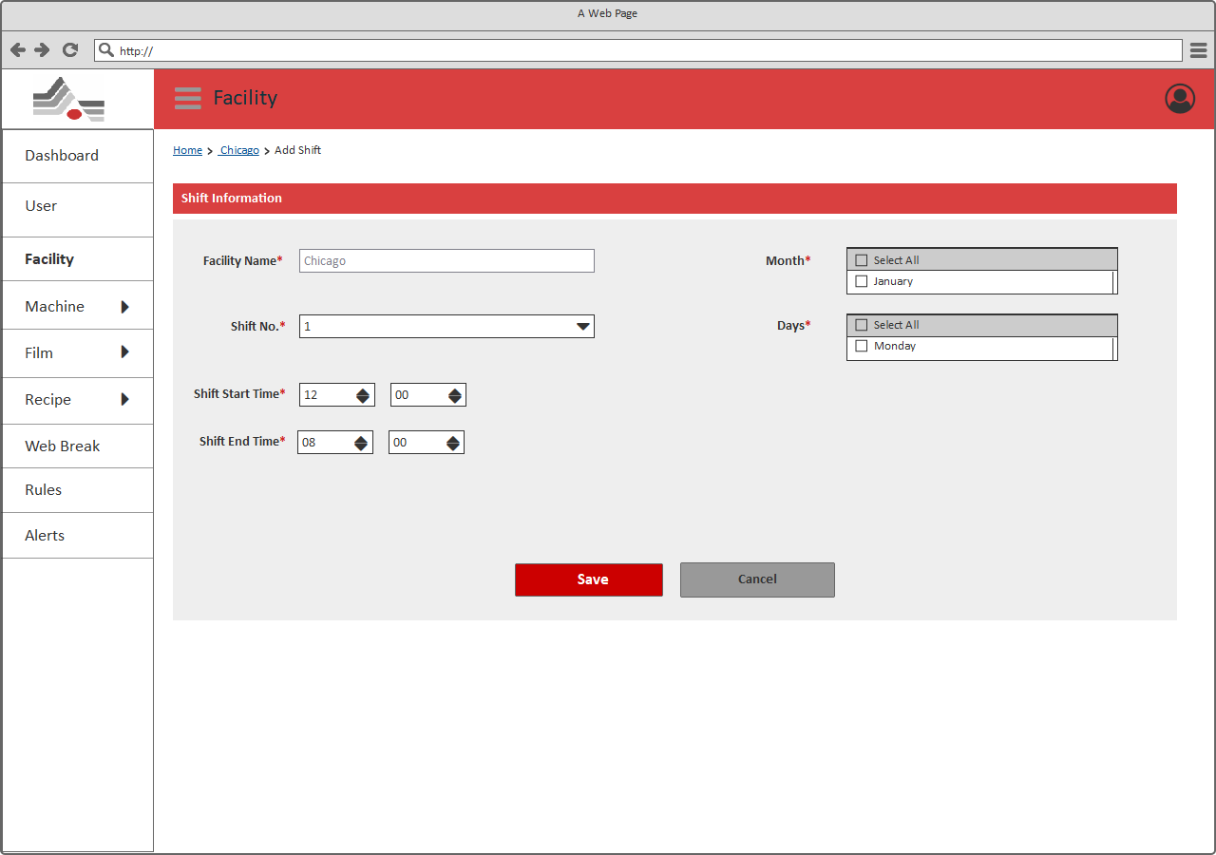

***[Add Shift]***

Description

As shown in above page, user should be able to add/edit Shift’s information through this page.

|  |  |  |  |  |
| --- | --- | --- | --- | --- |
| # | Field Name | Type | Mandatory (Y/N/NA) | Description |
| Page Header: User can view the title of the page (Facility) and should be able to perform below mentioned actions. | | | | |
| 1 | Breadcrumb | Link | NA | User will be able to view the breadcrumb/navigation of current page. Using the breadcrumb, user will be able to navigate to the previous navigations.  Depending on the module from where the user is accessing this page, information in the breadcrumb will be generated dynamically. |
| 2 | Facility Name | Textbox | Y  ‘Enter Facility Name’ | User will be able to View name of the facility.  **Note**:   1. It won’t allow to add facility name.   Edit: This field will contain the prefilled value based on the selected Shift from the Shift listing page. It won’t allow to edit facility name. |
| 3 | Month | Multi Select | Y  ‘Select Month’ | User will be able to select  the month of the shift.  **Note**:   1. One month should be selected.   Edit: This field will contain the prefilled value based on the selected Facility from the Shift listing page. |
| 4 | Shift No | Dropdown | Y  ‘Select Shift No’ | User will be able to select  the shift no. of the shift.  Edit: This field will contain the prefilled value based on the selected Facility from the Shift listing page. |
| 5 | Days | Multi Select | Y  ‘Select Days’ | User will be able to select  the days of the shift.  **Note**:   1. Days should be selected.   Edit: This field will contain the prefilled value based on the selected Facility from the Shift listing page. |
| 6 | Shift Start Time | Time Picker | Y  ‘Select Shift Start Time’ | User will be able to select  the start time of the shift.  Edit: This field will contain the prefilled value based on the selected Facility from the Shift listing page. |
| 7 | Shift End Time | Time Picker | Y  ‘Select Shift End Time’ | User will be able to select  the end time of the shift.  Edit: This field will contain the prefilled value based on the selected Facility from the Shift listing page. |
| 8 | Save & Add Shift | Button | NA | Clicking on Save will redirect to the Add Facility page |
| 9 | Cancel | Button | NA | Clicking on Cancel will redirect to the Add Facility page |

## Add/Edit Off Time

As shown in below “Add /Edit Off Time” page, Admin will be able to add/edit off time information. This page can be accessible from the “Add Facility” page, clicking on “Add Off Time” will redirect on this page.

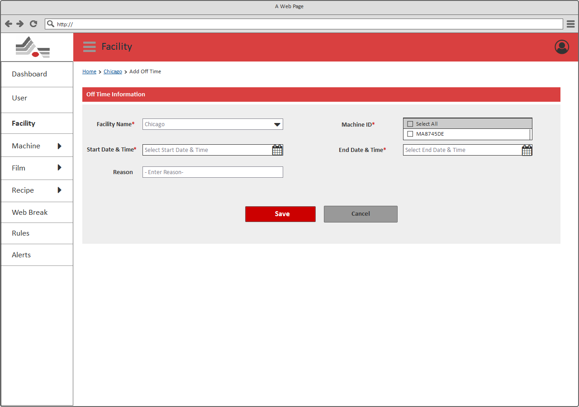

***[Add Off Time]***

Description

As shown in above page, user should be able to add/edit off time’s information through this page.

|  |  |  |  |  |
| --- | --- | --- | --- | --- |
| # | Field Name | Type | Mandatory (Y/N/NA) | Description |
| Page Header: User can view the title of the page (Facility) and should be able to perform below mentioned actions. | | | | |
| 1 | Breadcrumb | Link | NA | User will be able to view the breadcrumb/navigation of current page. Using the breadcrumb, user will be able to navigate to the previous navigations.  Depending on the module from where the user is accessing this page, information in the breadcrumb will be generated dynamically. |
| 2 | Facility Name | Textbox | Y  ‘Enter Facility Name’ | User will be able to add/updated name of the facility.  Edit: This field will contain the prefilled value based on the selected Off time from the Off Time listing page. |
| 3 | Machine ID | Multi Select | Y  ‘Select Machine | User will be able to select  machine of the off time.  **Note**:   1. One Machine ID should be selected.   Edit: This field will contain the prefilled value based on the selected Off time from the Off Time listing page. |
| 4 | Start Date &Time | Date &Time Picker | Y  ‘Select Start Date &Time’ | User will be able to select  the start time of the off time.  Edit: This field will contain the prefilled value based on the selected Off time from the Off Time listing page. |
| 5 | End Date &Time | Date &Time Picker | Y  ‘Select End Date &Time’ | User will be able to select  the End time of the off time.  **Note**:   1. End Date & Time should be less than start date & time.   Edit: This field will contain the prefilled value based on the selected Off time from the Off Time listing page. |
| 6 | Reason | Textbox | Y  ‘Enter reason’ | User will be able to enter  reason of the off time.  Edit: This field will contain the prefilled value based on the selected Off time from the Off Time listing page. |
| 7 | Save & Add Shift | Button | NA | Clicking on Save will redirect to the Add Off Time page |
| 8 | Cancel | Button | NA | Clicking on Cancel will redirect to the Add Off Time page |

## Machine Management

It allows to manage all machines and configure machine parameters from this section. This page can be accessible, by clicking on “Machine” menu from the left side navigation menu.

## Machine List

As shown in below “Machine List” page, Admin will be able to view list of Machine with its details.

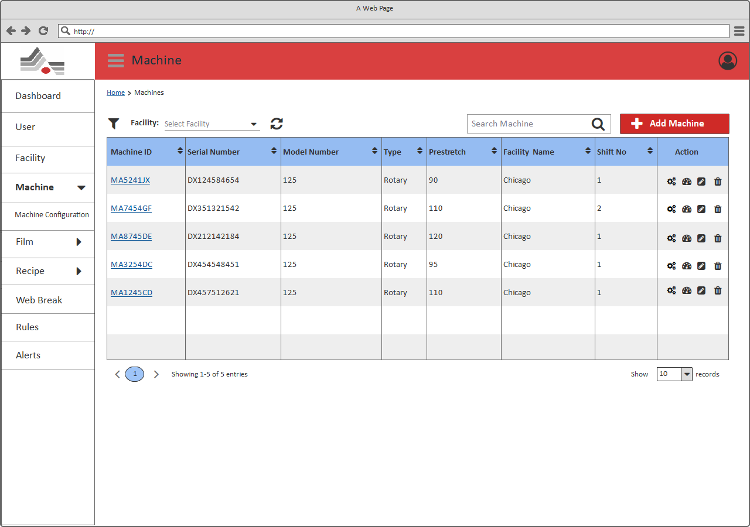

***[Machine List]***

Description

As shown in above page, User should be able to view the list of machines along with configure machine parameter, edit, delete and view dashboard options.

|  |  |  |  |  |
| --- | --- | --- | --- | --- |
| # | Field Name | Type | Mandatory (Y/N/NA) | Description |
| Page Header: User can view the title of the page (Machine) and should be able to perform below mentioned actions. | | | | |
| 1 | Breadcrumb | Link | NA | User will be able to view the breadcrumb/navigation of current page. Using the breadcrumb, user will be able to navigate to the previous navigations.  Depending on the module from where the user is accessing this page, information in the breadcrumb will be generated dynamically. |
| 2 | Filter | Dropdown | NA | User will be able to select “Facility” from the dropdown options. It allows to select single option from the dropdown. After selecting any option filter activity should be initiated. It displays list of machines fall underneath selected facility. |
| 2 | Search | Textbox | NA | User will be able to search any Machine through keyword search available on the page.  **Note**:   1. Search should be performed on all the existing machines and if the result comprises multiple pages, then user should be able to access the next/previous result pages through pagination option. 2. User should get a message “***No results found***” when no record found as per the keyword. |
| 3 | Add Machine | Button | NA | User will be redirected to the Add new machine page. |
| View list of Machines: Users should be able to view a list of all the existing machines with below mentioned details. If no machine is added into the system, page should display a message “*No machine exists*”. | | | | |
| 4 | Machine ID | Label | NA | User will be able to view ID of the existing machine.  **Note**:   1. User should be able to sort the Machine ID alphabetically through the sort icon available with Machine ID title in the grid. 2. By Clicking on machine ID, will redirect to machine detail page. Ref |
| 5 | Serial Number | Label | NA | User will be able to view serial number of the existing machine.  **Note**:   1. User should be able to sort the Serial Number ascending/descending through the sort icon available with Serial Number title in the grid. |
| 6 | Model Number | Label | NA | User will be able to view Model Number of the existing machine.  **Note**:   1. User should be able to sort the Model Number ascending/descending through the sort icon available with Model Number title in the grid. |
| 7 | Type | Label | NA | User will be able to view type of the existing machine.  **Note**:   1. User should be able to sort the type alphabetically through the sort icon available with Type title in the grid. |
| 8 | Pre-Stretch | Label | NA | User will be able to view Pre-Stretch of the existing machine.  **Note**:   1. User should be able to sort the Pre-stretch ascending/descending through the sort icon available with Pre-Stretch title in the grid. |
|  | Facility | Label | NA | User will be able to view Facility of the existing machine.  **Note**:   1. User should be able to sort the Facility alphabetically through the sort icon available with Facility title in the grid. |
| 9 | Shift No | Label | NA | User will be able to view shift No of the existing machine.  **Note**:   1. User should be able to sort the shift no ascending/descending through the sort icon available with Shift No. title in the grid. |
| 10 | Action | Icons | NA | User will be able to click on “” icon available with each machine to redirect configure machine parameter page for that particular machine.  User will be able to click on “” icon available with each machine to view Dashboard for that particular machine.  User will be able to edit any existing machine by clicking on “” icon available with each machine. It will redirect User to the Add/Edit Machine Page; with prefilled values of the selected Machine; where information can be added/modified.  User will be able to click on “” icon available with each machine to delete that particular machine.  **Note:**  1. By clicking on delete icon available with each record in the Machine’s list; it will display a pop-up with confirmation message such as ***“Are you sure you want to delete this Machine?”***  -- If User selects yes then the selected machine will be deleted else no action will be performed. |
| 11 | Pagination | Buttons | NA | User will be able to access the other machines through the pagination available on the page.  Clicking on the page numbers will navigate the User to that page which contains the machines. |
| 12 | Page Size | Dropdown | NA | User can also manage the number of items to be displayed into the list through a page size combo box with options10/25/50/100 items in a list.  **Note**: By default, only 10 Records will be displayed. |

## Add/Edit Machine

As shown in below “Add /Edit Machine” page, Admin will be able to add/edit machine. This page can be accessible form the “Machine List” page, clicking on “Add Machine” will redirect on this page.

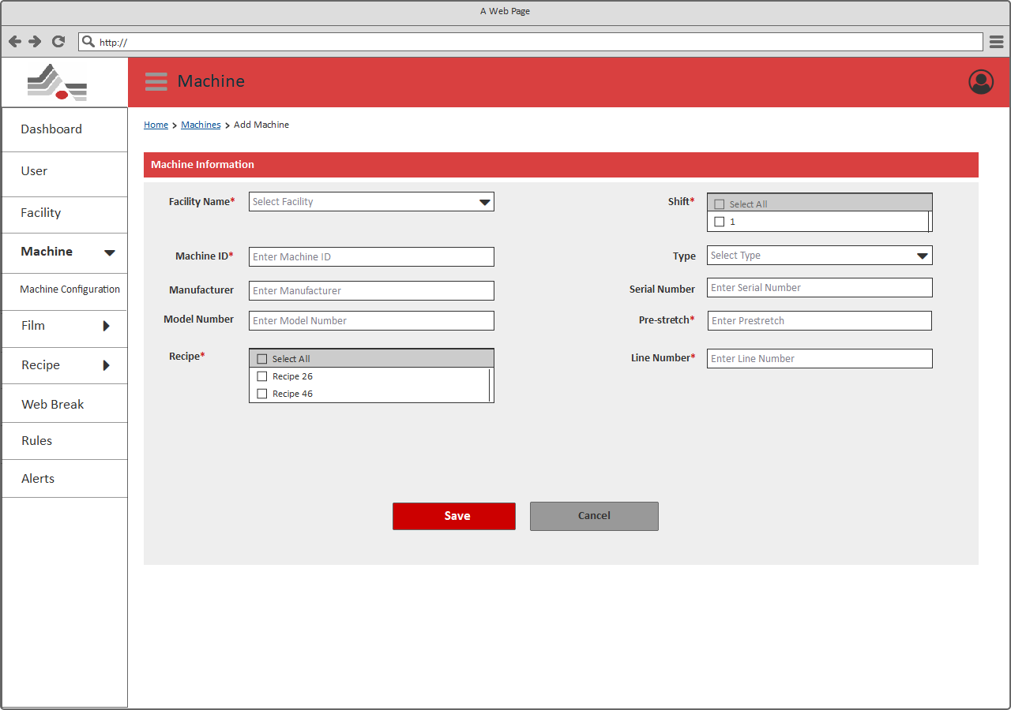

***[Add Machine]***

Description

As shown in above page, user should be able to add/edit machine’s information through this page.

|  |  |  |  |  |
| --- | --- | --- | --- | --- |
| # | Field Name | Type | Mandatory (Y/N/NA) | Description |
| Page Header: User can view the title of the page (Machine) and should be able to perform below mentioned actions. | | | | |
| 1 | Breadcrumb | Link | NA | User will be able to view the breadcrumb/navigation of current page. Using the breadcrumb, user will be able to navigate to the previous navigations.  Depending on the module from where the user is accessing this page, information in the breadcrumb will be generated dynamically. |
| 2 | Facility | Dropdown | Y  ‘Select Facility’ | User will be able to select/update facility from the Dropdown list.  Edit: This field will contain the prefilled value based on the selected Machine from the Machine listing page. |
| 3 | Shift | Multi Select | Y  ‘Select Shift’ | User will be able to select/update shift from the Dropdown list.  User has to assign one shift to the machine.  Edit: This field will contain the prefilled value based on the selected Machine from the Machine listing page. |
| 4 | Type | Dropdown | N | User will be able to select/update type from the machine list.  Edit: This field will contain the prefilled value based on the selected Machine from the Machine listing page. |
| 5 | Manufacturer | Textbox | N | User will be able to enter/update manufacturer of the machine.  Edit: This field will contain the prefilled value based on the selected Machine from the Machine listing page. |
| 6 | Serial Number | Textbox | N | User will be able to enter/update serial number of the machine.  Edit: This field will contain the prefilled value based on the selected Machine from the Machine listing page. |
| 7 | Model No | Textbox | N | User will be able to enter/update model no of the machine.  Edit: This field will contain the prefilled value based on the selected Machine from the Machine listing page. |
| 8 | Pre-Stretch | Textbox | Y  ‘Please enter Pre-Stretch’ | User will be able to enter/update pre-stretch of the machine.  **Note**:   1. Input of this field should be numbers only. If user has entered alphabets or special characters then it should display an error message, **“Please enter valid Pre-Stretch”** along with information of valid input type.   Edit: This field will contain the prefilled value based on the selected Machine from the Machine listing page. |
| 9 | Recipe | Multi Select | Y  ‘Select Facility’ | User will be able to select/update recipe from the Dropdown list.  User has to assign one recipe to the machine.  Edit: This field will contain the prefilled value based on the selected User from the User listing page. |
| 10 | Line Number | Textbox | Y  ‘Please enter Line Number’ | User will be able to enter/update line number of the machine.  **Note**:   1. Input of this field should be numbers only. If user has entered alphabets or special characters then it should display an error message, **“Please enter valid Line Number”** along with information of valid input type.   Edit: This field will contain the prefilled value based on the selected Machine from the Machine listing page. |
| 11 | Save | Button | NA | Clicking on Save will redirect to the Machine listing page |
| 12 | Cancel | Button | NA | Clicking on Cancel will redirect to the Machine listing page |

## Machine Detail

As shown in below “Machine Detail” page, Admin will be able to view Machine with its details.

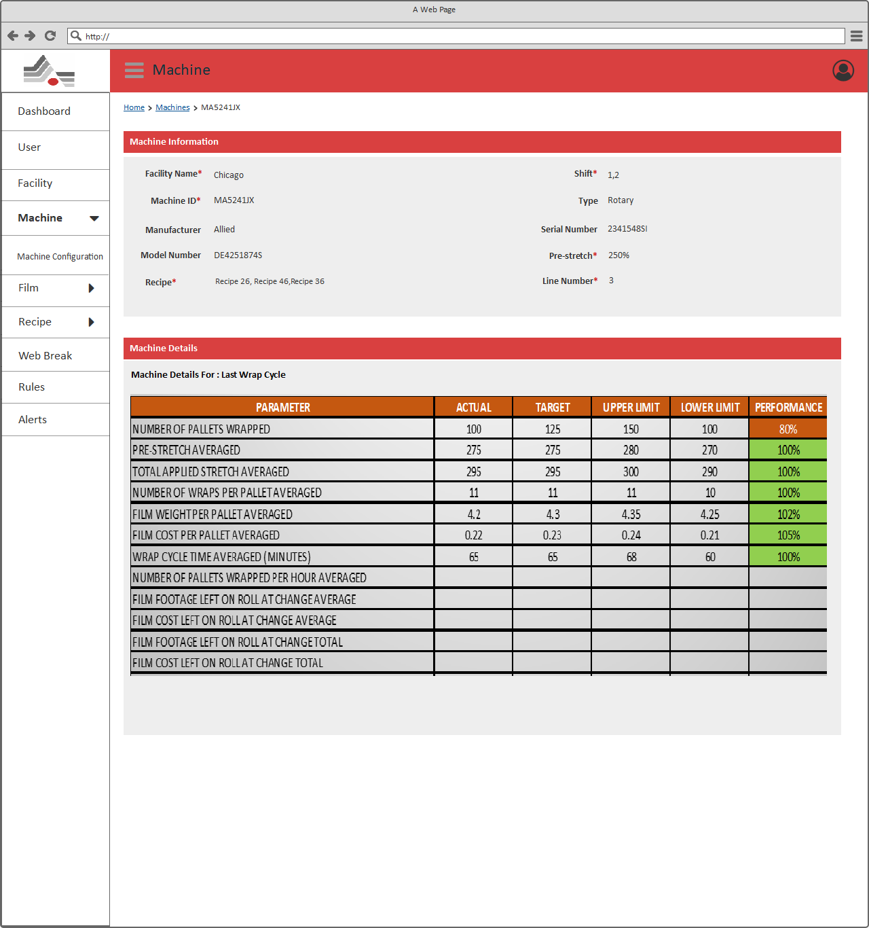

***[Machine Detail]***

Description

As shown in above page, User should be able to view the machine details.

|  |  |  |  |  |
| --- | --- | --- | --- | --- |
| # | Field Name | Type | Mandatory (Y/N/NA) | Description |
| Page Header: User can view the title of the page (Machine) and should be able to view below mentioned information. | | | | |
| 1 | Breadcrumb | Link | NA | User will be able to view the breadcrumb/navigation of current page. Using the breadcrumb, user will be able to navigate to the previous navigations.  Depending on the module from where the user is accessing this page, information in the breadcrumb will be generated dynamically. |
| Machine Information: Users should be able to view a list of all the existing machines with below mentioned details. If no machine is added into the system, page should display a message “*No machine exists*”. | | | | |
| 2 | Facility | Label | NA | User will be able to view Facility of the existing machine. |
| 3 | Machine ID | Label | NA | User will be able to view ID of the existing machine. |
| 4 | Shift | Label | NA | User will be able to view shift of the existing machine. |
| 5 | Type | Label | NA | User will be able to view type of the existing machine. |
| 6 | Manufacturer | Label | NA | User will be able to view manufacturer of the existing machine. |
| 7 | Model Number | Label | NA | User will be able to view Model Number of the existing machine. |
| 8 | Serial Number | Label | NA | User will be able to view Serial Number of the existing machine. |
| 9 | Pre-Stretch | Label | NA | User will be able to view Pre-Stretch of the existing machine. |
| 10 | Recipe | Label | NA | User will be able to view recipe of the existing machine. |
| 11 | Line Number | Label | NA | User will be able to view Line Number of the existing machine. |
| 12 | Machine Details | Label | NA | User will be able to view parameters of the machine in this section.  It should be populated configuration of the machine for last wrap cycle.  It shows following parameters in this section:   * Pre-Stretch * Number Of Pallet Wrapped/Hr. * Web Breaks   It shows above parameters actual, target, upper limit, lower limit and performance. |

## Machine Configuration

As shown in below “Machine Configuration” page, Admin will be able to view list of Machine configurations with its details.

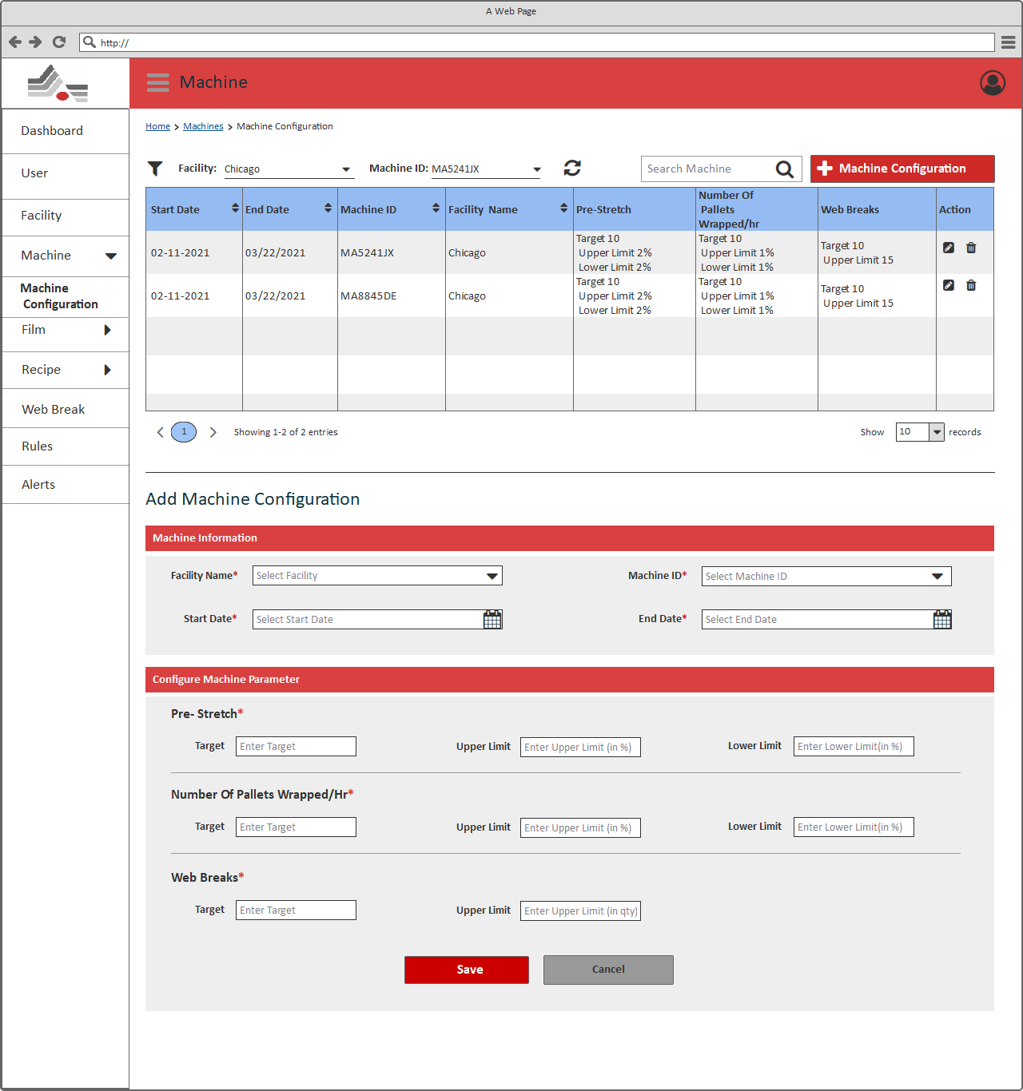

***[Machine Configuration]***

Description

As shown in above page, User should be able to view the list of machines along with configure machine parameter, edit, delete and view dashboard options.

|  |  |  |  |  |
| --- | --- | --- | --- | --- |
| # | Field Name | Type | Mandatory (Y/N/NA) | Description |
| Page Header: User can view the title of the page (Machine) and should be able to perform below mentioned actions. | | | | |
| 1 | Breadcrumb | Link | NA | User will be able to view the breadcrumb/navigation of current page. Using the breadcrumb, user will be able to navigate to the previous navigations.  Depending on the module from where the user is accessing this page, information in the breadcrumb will be generated dynamically. |
| 2 | Filter | Dropdown | NA | User will be able to select “Facility” and “Machine” from the dropdown options. It allows to select single option from the dropdown. After selecting any option filter activity should be initiated. It displays list of configurations fall underneath selected facility and machine. |
| 3 | Search | Textbox | NA | User will be able to search any configurations through keyword search available on the page.  **Note**:   1. Search should be performed on all the existing configurations and if the result comprises multiple pages, then user should be able to access the next/previous result pages through pagination option. 2. User should get a message “***No results found***” when no record found as per the keyword. |
| 4 | Add Machine Configuration | Button | NA | User will be redirected to the Add new machine configuration section. Ref: |
| View list of Machines: Users should be able to view a list of all the existing machine’s configurations with below mentioned details. If no configuration is added into the system, page should display a message “*No Configuration exists*”. | | | | |
| 5 | Start Date | Label | NA | User will be able to view start date of the existing machine’s configuration.  **Note**:   1. User should be able to sort the Start Date Oldest/Newest through the sort icon available with Start Date title in the grid. |
| 6 | End Date | Label | NA | User will be able to view end date of the existing machine’s configuration.  **Note**:   1. User should be able to sort the End Date Oldest/Newest through the sort icon available with End Date title in the grid. |
| 7 | Machine ID | Label | NA | User will be able to view ID of the existing machine.  **Note**:   1. User should be able to sort the Machine ID alphabetically through the sort icon available with Machine ID title in the grid. |
| 8 | Facility | Label | NA | User will be able to view Facility of the existing machine.  **Note**:   1. User should be able to sort the Facility alphabetically through the sort icon available with Facility title in the grid. |
| 9 | Pre-Stretch | Label | NA | User will be able to view Pre-Stretch of the existing machine. |
| 10 | Number of pallets wrapped/hr | Label | NA | User will be able to view number of pallets wrapped/hr of the existing machine. |
| 11 | Web Breaks | Label | NA | User will be able to view web breaks of the existing machine. |
| 12 | Action | Icons | NA | User will be able to edit any existing machine configuration by clicking on “” icon available with each machine. It will redirect User to the Add/Edit Configuration Page; with prefilled values of the selected Machine; where information can be added/modified.  User will be able to click on “” icon available with each machine to delete that particular configuration.  **Note:**  1. By clicking on delete icon available with each record in the Configuration list; it will display a pop-up with confirmation message such as ***“Are you sure you want to delete this Configuration?”***  -- If User selects yes then the selected configuration will be deleted else no action will be performed. |
| 13 | Pagination | Buttons | NA | User will be able to access the other configurations through the pagination available on the page.  Clicking on the page numbers will navigate the User to that page which contains the configurations. |
| 14 | Page Size | Dropdown | NA | User can also manage the number of items to be displayed into the list through a page size combo box with options10/25/50/100 items in a list.  **Note**: By default, only 10 Records will be displayed. |
| Add Machine Configuration: User will be able to add below mention information to configure machine parameter in this section. | | | | |
| 15 | Facility Name | Dropdown | NA | User will be able to select/update facility from the Dropdown list.  Edit: This field will contain the prefilled value based on the selected Configuration from the Configuration listing page. |
| 16 | Machine ID | Dropdown | NA | User will be able to select/update Machine ID from the Dropdown list.  Edit: This field will contain the prefilled value based on the selected Configuration from the Configuration listing page. |
| 17 | Start Date | Date Picker | NA | User will be able to select/update start date from the date picker.  Edit: This field will contain the prefilled value based on the selected Configuration from the Configuration listing page. |
| 18 | End Date | Date Picker | NA | User will be able to select/update end date from the date picker.  **Note**:   1. End Date should be less than start date.   Edit: This field will contain the prefilled value based on the selected Configuration from the Configuration listing page. |
| Configure Machine Parameter – User will be able to add below mentioned configuration parameters for the machine. | | | | |
| 19 | Pre-Stretch | Text box | Y  ‘Please Enter Pre-stretch’ | User will be able to enter/update pre-stretch value.  It allows to enter below value of below mentioned parameters:  **Note:**   1. **Target**: It allows to enter target of pre-stretch for the machine. It should be numbers only. 2. **Upper Limit**: It allows to enter pre-stretch upper limit for the machine. It should be numbers only. Value of this field should be entered in percentage. 3. **Lower Limit**: It allows to enter pre-stretch lower limit for the machine. It should be numbers only. Value of this field should be entered in percentage   Edit: This field will contain the prefilled value based on the selected Configuration from the Configuration listing page. |
| 20 | Number Of Pallets Wrapped/Hr | Text box | Y  ‘Please Enter Number Of Pallets Wrapped/Hr’ | User will be able to enter/update Number Of Pallets Wrapped/Hr value.  It allows to enter below value of below mentioned parameters:  **Note:**   1. **Target**: It allows to enter target Of Number of Pallets Wrapped/Hr for the machine. It should be numbers only. 2. **Upper Limit**: It allows to enter Number Of Pallets Wrapped/Hr upper limit for the machine. It should be numbers only. Value of this field should be entered in percentage. 3. **Lower Limit**: It allows to enter Number Of Pallets Wrapped/Hr lower limit for the machine. It should be numbers only. Value of this field should be entered in percentage   Edit: This field will contain the prefilled value based on the selected Configuration from the Configuration listing page. |
| 21 | Web Breaks | Text box | Y  ‘Please Enter Web Breaks | User will be able to enter/update Web Breaks value.  It allows to enter below value of below mentioned parameters:  **Note:**   1. **Target**: It allows to enter Web Breaks target for the machine. It should be numbers only. 2. **Upper Limit**: It allows to enter web breaks upper limit for the machine. It should be numbers only. Value of this field should be entered in percentage.   Edit: This field will contain the prefilled value based on the selected Configuration from the Configuration listing page. |
| 22 | Save | Button | NA | Clicking on Save will redirect to the Machine Configuration page |
| 23 | Cancel | Button | NA | Clicking on Cancel will redirect to the Machine Configuration page |

## Film Management

It allows to manage all films and configure film parameters from this section. This page can be accessible, by clicking on “Film” menu from the left side navigation menu.

## Film List

As shown in below “Film List” page, Admin will be able to view list of Film with its details.

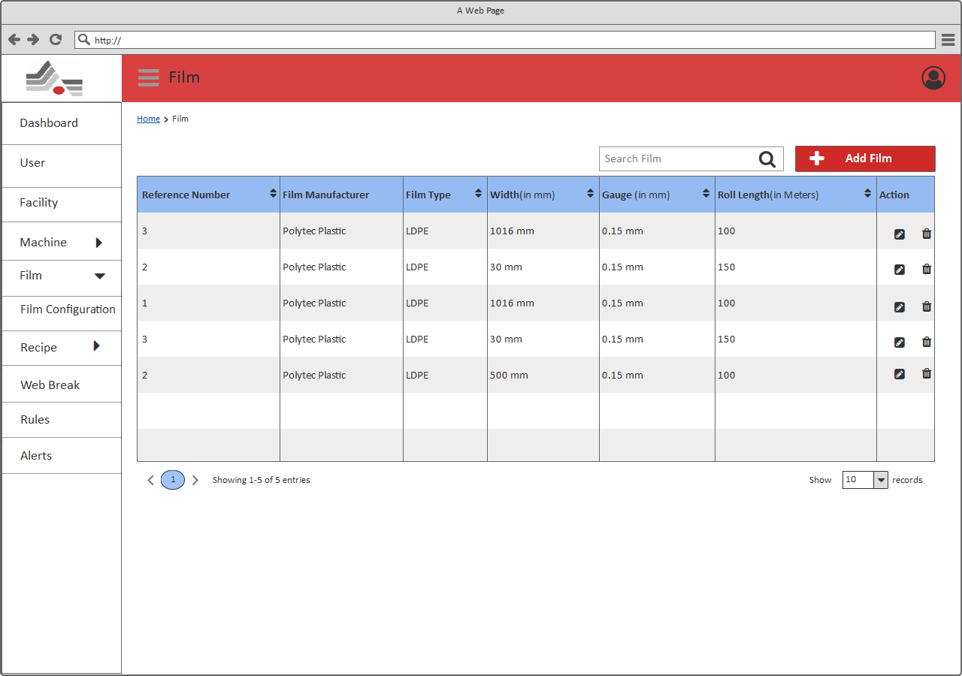

***[Film List]***

Description

As shown in above page, User should be able to view the list of films along with edit and delete options.

|  |  |  |  |  |
| --- | --- | --- | --- | --- |
| # | Field Name | Type | Mandatory (Y/N/NA) | Description |
| Page Header: User can view the title of the page (Film) and should be able to perform below mentioned actions. | | | | |
| 1 | Breadcrumb | Link | NA | User will be able to view the breadcrumb/navigation of current page. Using the breadcrumb, user will be able to navigate to the previous navigations.  Depending on the module from where the user is accessing this page, information in the breadcrumb will be generated dynamically. |
| 2 | Search | Textbox | NA | User will be able to search any Film through keyword search available on the page.  **Note**:   1. Search should be performed on all the existing Films and if the result comprises multiple pages, then user should be able to access the next/previous result pages through pagination option. 2. User should get a message “***No results found***” when no record found as per the keyword. |
| 3 | Add Film | Button | NA | User will be redirected to the Add new Film page. |
| View list of Films: Users should be able to view a list of all the existing Films with below mentioned details. If no Film is added into the system, page should display a message “*No Film exists*”. | | | | |
| 4 | Reference Number | Label | NA | User will be able to view reference number of the existing Film.  **Note**:   1. User should be able to sort the Reference Number ascending/descending through the sort icon available with Reference Number title in the grid. |
| 5 | Film Manufacturer | Label | NA | User will be able to view serial manufacturer of the existing Film. |
| 6 | Film Type | Label | NA | User will be able to view type of the existing Film.  **Note**:   1. User should be able to sort the type alphabetically through the sort icon available with Film Type title in the grid. |
| 7 | Width (in mm) | Label | NA | User will be able to view width of the existing Film.  **Note**:   1. User should be able to sort the width ascending/descending through the sort icon available with Width title in the grid. |
| 8 | Gauge (in mm) | Label | NA | User will be able to view gauge of the existing Film.  **Note**:   1. User should be able to sort the gauge ascending/descending through the sort icon available with Gauge title in the grid. |
| 9 | Roll Length (in Meters) | Label | NA | User will be able to view roll length of the existing Film.  **Note**:   1. User should be able to sort the roll length ascending/descending through the sort icon available with Roll Length title in the grid. |
| 10 | Action | Icons | NA | User will be able to edit any existing Film by clicking on “” icon available with each Film. It will redirect User to the Add/Edit Film Page; with prefilled values of the selected Film; where information can be added/modified.  User will be able to click on “” icon available with each Film to delete that particular Film.  **Note:**  1. By clicking on delete icon available with each record in the Film’s list; it will display a pop-up with confirmation message such as ***“Are you sure you want to delete this Film?”***  -- If User selects yes then the selected Film will be deleted else no action will be performed. |
| 11 | Pagination | Buttons | NA | User will be able to access the other films through the pagination available on the page.  Clicking on the page numbers will navigate the User to that page which contains the films. |
| 12 | Page Size | Dropdown | NA | User can also manage the number of items to be displayed into the list through a page size combo box with options10/25/50/100 items in a list.  **Note**: By default, only 10 Records will be displayed. |

## Add/Edit Film

As shown in below “Add /Edit Film” page, Admin will be able to add/edit Film. This page can be accessible form the “Film List” page, clicking on “Add Film” will redirect on this page.

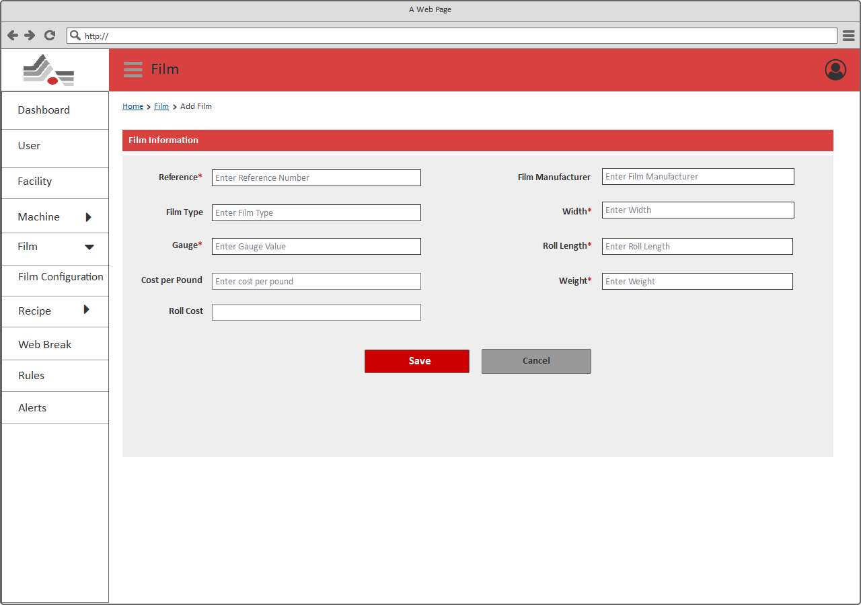

***[Add Film]***

Description

As shown in above page, user should be able to add/edit Film’s information through this page.

|  |  |  |  |  |
| --- | --- | --- | --- | --- |
| # | Field Name | Type | Mandatory (Y/N/NA) | Description |
| Page Header: User can view the title of the page (Film) and should be able to perform below mentioned actions. | | | | |
| 1 | Breadcrumb | Link | NA | User will be able to view the breadcrumb/navigation of current page. Using the breadcrumb, user will be able to navigate to the previous navigations.  Depending on the module from where the user is accessing this page, information in the breadcrumb will be generated dynamically. |
| 2 | Reference Number | Text box | Y  ‘Enter Reference Number’ | User will be able to enter/update reference number of the film.  **Note**:   1. Input of this field should be numbers only. If user has entered alphabets or special characters then it should display an error message, **“Please enter valid Reference Number”** along with information of valid input type.   Edit: This field will contain the prefilled value based on the selected Film from the Film listing page. |
| 3 | Film Manufacturer | Text box | Y  ‘Enter Film Manufacturer’ | User will be able to enter/update Manufacturer of the film.  Edit: This field will contain the prefilled value based on the selected Film from the Film listing page. |
| 4 | Film Type | Text box | N | User will be able to enter/update type from the Film.  Edit: This field will contain the prefilled value based on the selected Film from the Film listing page. |
| 5 | Width | Text box | Y  ‘Enter Width’ | User will be able to enter/update width of the Film.  **Note**:   1. Input of this field should be numbers only. If user has entered alphabets or special characters then it should display an error message, **“Please enter valid width”** along with information of valid input type.   Edit: This field will contain the prefilled value based on the selected Film from the Film listing page. |
| 6 | Gauge | Text box | Y  ‘Enter Gauge’ | User will be able to enter/update gauge of the Film.  **Note**:   1. Input of this field should be numbers only. If user has entered alphabets or special characters then it should display an error message, **“Please enter valid Gauge”** along with information of valid input type.   Edit: This field will contain the prefilled value based on the selected Film from the Film listing page. |
| 7 | Roll Length | Text box | Y  ‘Enter Roll Length’ | User will be able to enter/update roll length of the Film.  **Note**:   1. Input of this field should be numbers only. If user has entered alphabets or special characters then it should display an error message, **“Please enter valid Roll Length”** along with information of valid input type.   Edit: This field will contain the prefilled value based on the selected Film from the Film listing page. |
| 8 | Cost per Pound | Textbox | N | User will be able to enter/update cost per pound of the Film.  **Note**:   1. Input of this field should be numbers only. If user has entered alphabets or special characters then it should display an error message, **“Please enter valid Cost per Pound”** along with information of valid input type.   Edit: This field will contain the prefilled value based on the selected Film from the Film listing page. |
| 9 | Weight | Textbox | N | User will be able to enter/update weight of the Film.  **Note**:   1. Input of this field should be numbers only. If user has entered alphabets or special characters then it should display an error message, **“Please enter valid Weight”** along with information of valid input type.   Edit: This field will contain the prefilled value based on the selected Film from the Film listing page. |
| 10 | Roll Cost | Textbox | N | User will be able to view roll cost of the Film.  Edit: This field will contain the prefilled value based on the selected Film from the Film listing page. It will not be editable. |
| 11 | Save | Button | NA | Clicking on Save will redirect to the Film listing page |
| 12 | Cancel | Button | NA | Clicking on Cancel will redirect to the Film listing page |

## Film Configuration

As shown in below “Film Configuration” page, Admin will be able to view list of Film configurations with its details. This page can be accessible, by clicking on “Film Configuration” submenu from the left side navigation menu.

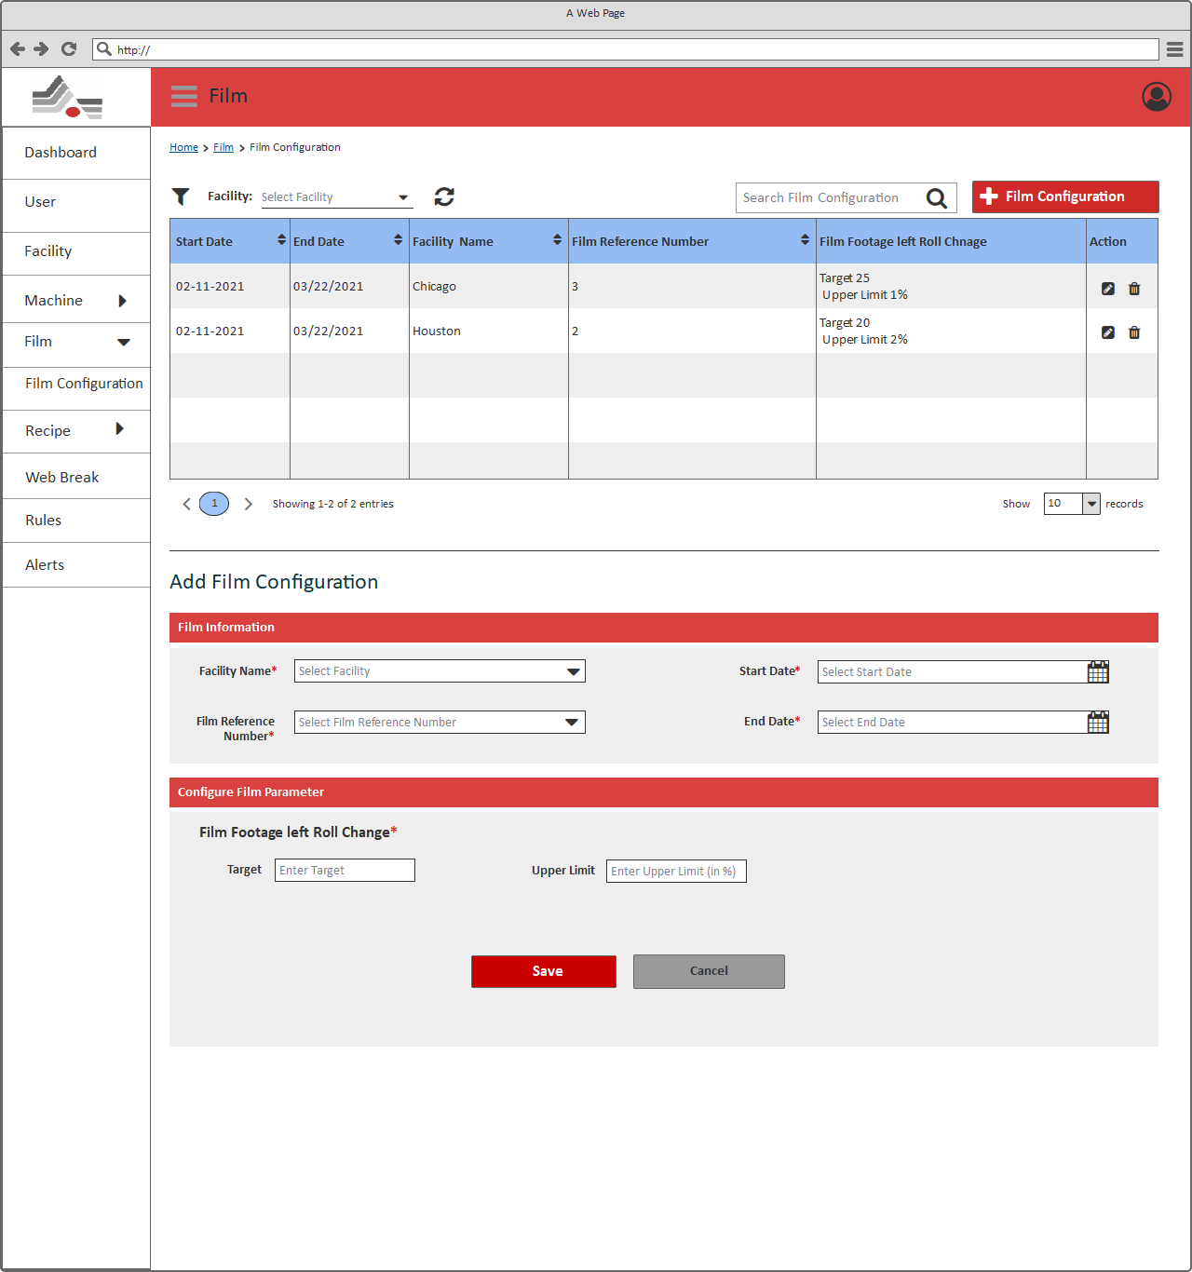

***[Film Configuration]***

Description

As shown in above page, User should be able to view the list of film configurations along with edit, and delete options.

|  |  |  |  |  |
| --- | --- | --- | --- | --- |
| # | Field Name | Type | Mandatory (Y/N/NA) | Description |
| Page Header: User can view the title of the page (Film) and should be able to perform below mentioned actions. | | | | |
| 1 | Breadcrumb | Link | NA | User will be able to view the breadcrumb/navigation of current page. Using the breadcrumb, user will be able to navigate to the previous navigations.  Depending on the module from where the user is accessing this page, information in the breadcrumb will be generated dynamically. |
| 2 | Filter | Dropdown | NA | User will be able to select “Facility” and “Film” from the dropdown options. It allows to select single option from the dropdown. After selecting any option filter activity should be initiated. It displays list of configurations fall underneath selected facility. |
| 3 | Search | Textbox | NA | User will be able to search any configurations through keyword search available on the page.  **Note**:   1. Search should be performed on all the existing configurations and if the result comprises multiple pages, then user should be able to access the next/previous result pages through pagination option. 2. User should get a message “***No results found***” when no record found as per the keyword. |
| 4 | Add Film Configuration | Button | NA | User will be redirected to the Add new Film configuration section. Ref: |
| View list of Films: Users should be able to view a list of all the existing Film’s configurations with below mentioned details. If no configuration is added into the system, page should display a message “*No Configuration exists*”. | | | | |
| 5 | Start Date | Label | NA | User will be able to view start date of the existing Film’s configuration.  **Note**:   1. User should be able to sort the Start Date Oldest/Newest through the sort icon available with Start Date title in the grid. |
|  | End Date | Label | NA | User will be able to view end date of the existing Film’s configuration.  **Note**:   1. User should be able to sort the End Date Oldest/Newest through the sort icon available with End Date title in the grid. |
| 6 | Facility | Label | NA | User will be able to view Facility of the existing Film.  **Note**:   1. User should be able to sort the Facility alphabetically through the sort icon available with Facility title in the grid. |
| 7 | Film Reference Number | Label | NA | User will be able to view reference number of the existing Film.  **Note**:   1. User should be able to sort the Film Reference Number ascending/descending through the sort icon available with Film Reference Number title in the grid. |
| 8 | Film Footage left Roll Change | Label | NA | User will be able to view Film Footage left Roll Change of the existing Film. |
| 9 | Action | Icons | NA | User will be able to edit any existing Film configuration by clicking on “” icon available with each Film. It will redirect User to the Add/Edit Configuration Page; with prefilled values of the selected Film; where information can be added/modified.  User will be able to click on “” icon available with each Film to delete that particular configuration.  **Note:**  1. By clicking on delete icon available with each record in the Configuration list; it will display a pop-up with confirmation message such as ***“Are you sure you want to delete this Configuration?”***  -- If User selects yes then the selected configuration will be deleted else no action will be performed. |
| 10 | Pagination | Buttons | NA | User will be able to access the other configurations through the pagination available on the page.  Clicking on the page numbers will navigate the User to that page which contains the configurations. |
| 11 | Page Size | Dropdown | NA | User can also manage the number of items to be displayed into the list through a page size combo box with options10/25/50/100 items in a list.  **Note**: By default, only 10 Records will be displayed. |
| Add Film Configuration: User will be able to add below mention information to configure Film parameter in this section. | | | | |
| 12 | Facility Name | Dropdown | NA | User will be able to select/update facility from the Dropdown list.  Edit: This field will contain the prefilled value based on the selected Configuration from the Configuration listing page. |
| 13 | Film Reference Number | Dropdown | NA | User will be able to select/update Film Reference number.  Edit: This field will contain the prefilled value based on the selected Configuration from the Configuration listing page. |
| 14 | Start Date | Date Picker | NA | User will be able to select/update start date from the date picker.  Edit: This field will contain the prefilled value based on the selected Configuration from the Configuration listing page. |
| 15 | End Date | Date Picker | NA | User will be able to select/update end date from the date picker.  **Note**:   1. End Date should be less than start date.   Edit: This field will contain the prefilled value based on the selected Configuration from the Configuration listing page. |
| 16 | Film ID | Dropdown | NA | User will be able to select/update Film ID from the Dropdown list.  Edit: This field will contain the prefilled value based on the selected Configuration from the Configuration listing page. |
| Configure Film Parameter – User will be able to add below mentioned configuration parameters for the Film. | | | | |
| 17 | Film Footage left Roll Change | Text box | Y  ‘Please Enter Pre-stretch’ | User will be able to enter/update Film Footage left Roll Change.  It allows to enter below value of below mentioned parameters:  **Note:**   1. **Target**: It allows to enter target of Film Footage left Roll Change for the Film. It should be numbers only. 2. **Upper Limit**: It allows to enter Film Footage left Roll Change upper limit for the Film. It should be numbers only. Value of this field should be entered in percentage.   Edit: This field will contain the prefilled value based on the selected Configuration from the Configuration listing page. |
| 18 | Save | Button | NA | Clicking on Save will redirect to the Film Configuration page |
| 19 | Cancel | Button | NA | Clicking on Cancel will redirect to the Film Configuration page |

## Recipe Management

It allows to manage all Recipes and configure Recipe parameters from this section. This page can be accessible, by clicking on “Recipe” menu from the left side navigation menu.

## Recipe List

As shown in below “Recipe List” page, Admin will be able to view list of Recipe with its details.

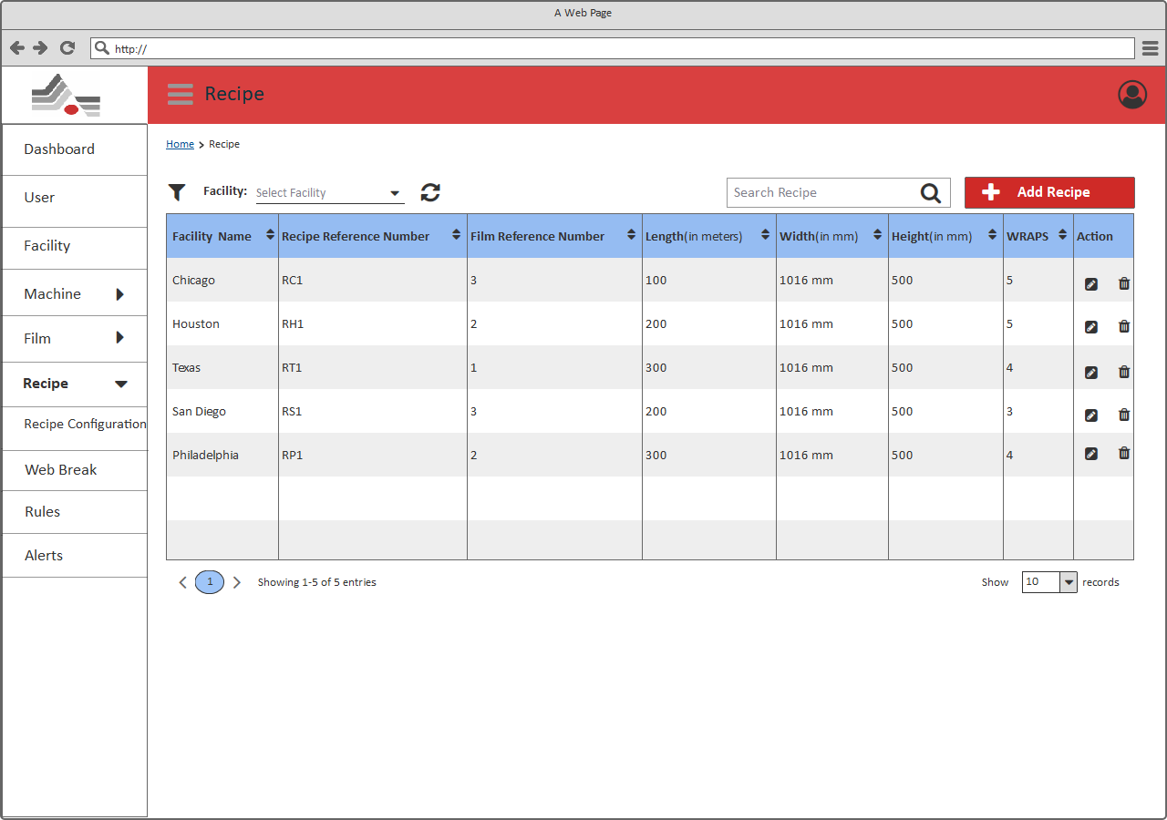

***[Recipe List]***

Description

As shown in above page, User should be able to view the list of Recipes along edit, and delete options.

|  |  |  |  |  |
| --- | --- | --- | --- | --- |
| # | Field Name | Type | Mandatory (Y/N/NA) | Description |
| Page Header: User can view the title of the page (Recipe) and should be able to perform below mentioned actions. | | | | |
| 1 | Breadcrumb | Link | NA | User will be able to view the breadcrumb/navigation of current page. Using the breadcrumb, user will be able to navigate to the previous navigations.  Depending on the module from where the user is accessing this page, information in the breadcrumb will be generated dynamically. |
| 2 | Filter | Dropdown | NA | User will be able to select “Facility” from the dropdown options. It allows to select single option from the dropdown. After selecting any option filter activity should be initiated. It displays list of Recipes fall underneath selected facility. |
| 3 | Search | Textbox | NA | User will be able to search any recipe through keyword search available on the page.  **Note**:   1. Search should be performed on all the existing recipes and if the result comprises multiple pages, then user should be able to access the next/previous result pages through pagination option. 2. User should get a message “***No results found***” when no record found as per the keyword. |
| 4 | Add Recipe | Button | NA | User will be redirected to the Add new Recipe page. |
| View list of Recipes: Users should be able to view a list of all the existing Recipes with below mentioned details. If no Recipe is added into the system, page should display a message “*No Recipe exists*”. | | | | |
| 5 | Facility Name | Label | NA | User will be able to view facility name of the existing Recipe.  **Note**:   1. User should be able to sort the Facility Name alphabetically through the sort icon available with Facility Name title in the grid. |
| 6 | Recipe Reference Number | Label | NA | User will be able to view reference number of the existing Recipe.  **Note**:   1. User should be able to sort the Reference Number alphabetically through the sort icon available with Reference Number title in the grid. |
| 7 | Film Reference Number | Label | NA | User will be able to view film reference number of the existing Recipe.  **Note**:   1. User should be able to sort the Film Reference Number ascending/descending through the sort icon available with film Reference Number title in the grid. |
| 8 | Length (in Meters) | Label | NA | User will be able to view length of the existing Recipe.  **Note**:   1. User should be able to sort the length ascending/descending through the sort icon available with length title in the grid. |
| 9 | Width (in mm) | Label | NA | User will be able to view width of the existing Recipe.  **Note**:   1. User should be able to sort the width ascending/descending through the sort icon available with Width title in the grid. |
| 10 | Height (in mm) | Label | NA | User will be able to view height of the existing Recipe.  **Note**:   1. User should be able to sort the height ascending/descending through the sort icon available with height title in the grid. |
| 11 | WRAPS | Label | NA | User will be able to view WRAPS of the existing Recipe.  **Note**:   1. User should be able to sort the WRAPS ascending/descending through the sort icon available with WRAPS title in the grid. |
| 12 | Action | Icons | NA | User will be able to edit any existing Recipe by clicking on “” icon available with each Recipe. It will redirect User to the Add/Edit Recipe Page; with prefilled values of the selected Recipe; where information can be added/modified.  User will be able to click on “” icon available with each Recipe to delete that particular Recipe.  **Note:**  1. By clicking on delete icon available with each record in the Recipe’s list; it will display a pop-up with confirmation message such as ***“Are you sure you want to delete this Recipe?”***  -- If User selects yes then the selected Recipe will be deleted else no action will be performed. |
| 13 | Pagination | Buttons | NA | User will be able to access the other recipes through the pagination available on the page.  Clicking on the page numbers will navigate the User to that page which contains the recipes. |
| 14 | Page Size | Dropdown | NA | User can also manage the number of items to be displayed into the list through a page size combo box with options10/25/50/100 items in a list.  **Note**: By default, only 10 Records will be displayed. |

## Add/Edit Recipe

As shown in below “Add /Edit Recipe” page, Admin will be able to add/edit Recipe. This page can be accessible form the “Recipe List” page, clicking on “Add Recipe” will redirect on this page.

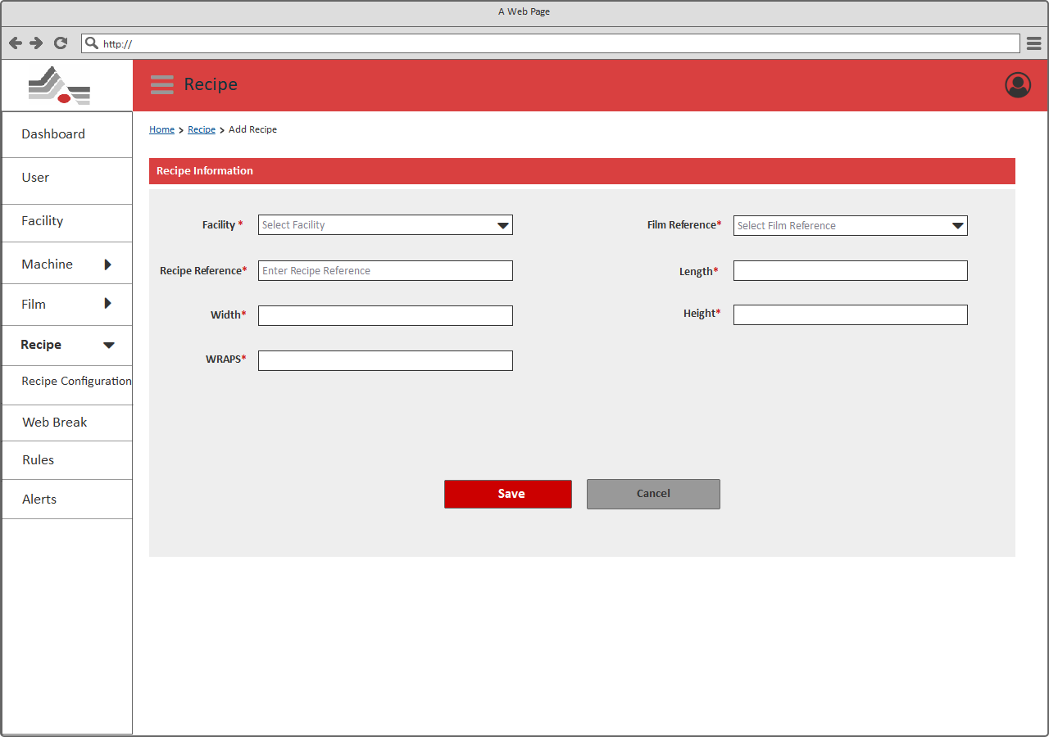

***[Add Recipe]***

Description

As shown in above page, user should be able to add/edit Recipe’s information through this page.

|  |  |  |  |  |
| --- | --- | --- | --- | --- |
| # | Field Name | Type | Mandatory (Y/N/NA) | Description |
| Page Header: User can view the title of the page (Recipe) and should be able to perform below mentioned actions. | | | | |
| 1 | Breadcrumb | Link | NA | User will be able to view the breadcrumb/navigation of current page. Using the breadcrumb, user will be able to navigate to the previous navigations.  Depending on the module from where the user is accessing this page, information in the breadcrumb will be generated dynamically. |
| 2 | Facility | Dropdown | Y  ‘Select Facility’ | User will be able to select/update facility from the Dropdown list.  Edit: This field will contain the prefilled value based on the selected Recipe from the Recipe listing page. |
| 3 | Film Reference Number | Dropdown | Y  ‘Select Film Reference Number’ | User will be able to select/update film reference number from the Dropdown list.  Edit: This field will contain the prefilled value based on the selected Recipe from the Recipe listing page. |
| 4 | Recipe Reference Number | Text box | Y  ‘Select Recipe Reference Number’ | User will be able to enter/update recipe reference number.  **Note**:   1. Input of this field should be alphanumeric. If user has entered special characters then it should display an error message, **“Please enter valid Recipe Reference Number”** along with information of valid input type.   Edit: This field will contain the prefilled value based on the selected Recipe from the Recipe listing page. |
| 5 | Length | Textbox | NA | User will be able to view Length of the Recipe. Based on film reference number, value of this field should be auto populated.  Edit: This field will contain the prefilled value based on the selected Recipe from the Recipe listing page.  This field won’t editable. |
| 6 | Width | Textbox | NA | User will be able to view width of the Recipe. Based on film reference number, value of this field should be auto populated.  **Note**:   1. Input of this field should be numbers only. If user has entered alphabets or special characters then it should display an error message, **“Please enter valid width”** along with information of valid input type.   Edit: This field will contain the prefilled value based on the selected Recipe from the Recipe listing page.  This field won’t editable. |
| 7 | Height | Textbox | Y  ‘Please enter Height’ | User will be able to enter/update height of the Recipe.  **Note**:   1. Input of this field should be numbers only. If user has entered alphabets or special characters then it should display an error message, **“Please enter valid Height”** along with information of valid input type.   Edit: This field will contain the prefilled value based on the selected Recipe from the Recipe listing page. |
| 8 | WRAPS | Textbox | Y  ‘Please enter WRAPS’ | User will be able to enter/update pre-stretch of the Recipe.  **Note**:   1. Input of this field should be numbers only. If user has entered alphabets or special characters then it should display an error message, **“Please enter valid WRAPS”** along with information of valid input type.   Edit: This field will contain the prefilled value based on the selected Recipe from the Recipe listing page. |
| 9 | Save | Button | NA | Clicking on Save will redirect to the Recipe listing page |
| 10 | Cancel | Button | NA | Clicking on Cancel will redirect to the Recipe listing page |

## Recipe Configuration

As shown in below “Recipe Configuration” page, Admin will be able to view list of Recipe configurations with its details.

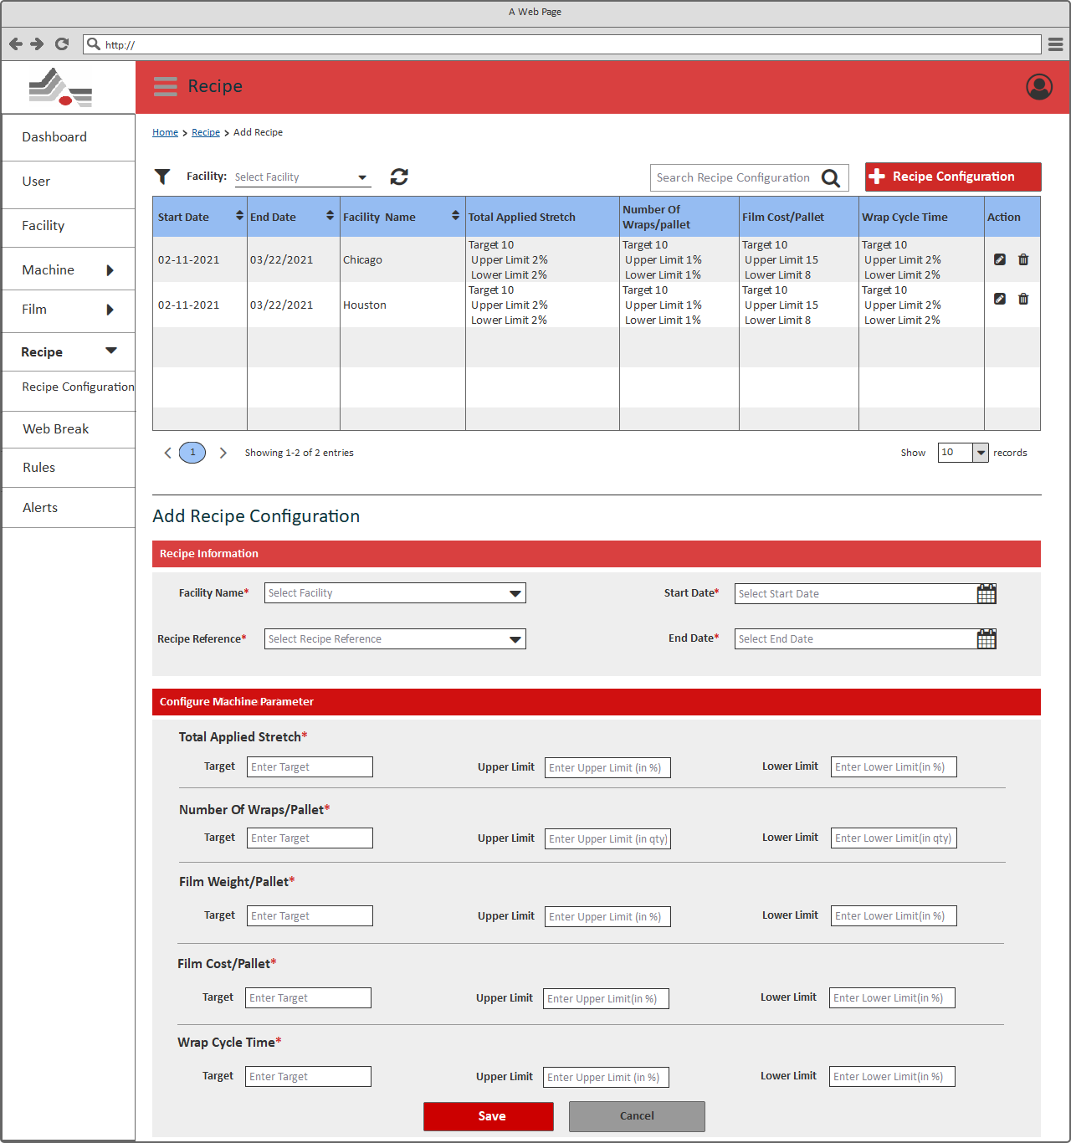

***[Recipe Configuration]***

Description

As shown in above page, User should be able to view the list of Recipes along with configure Recipe parameter, edit, delete and view dashboard options.

|  |  |  |  |  |
| --- | --- | --- | --- | --- |
| # | Field Name | Type | Mandatory (Y/N/NA) | Description |
| Page Header: User can view the title of the page (Recipe) and should be able to perform below mentioned actions. | | | | |
| 1 | Breadcrumb | Link | NA | User will be able to view the breadcrumb/navigation of current page. Using the breadcrumb, user will be able to navigate to the previous navigations.  Depending on the module from where the user is accessing this page, information in the breadcrumb will be generated dynamically. |
| 2 | Filter | Dropdown | NA | User will be able to select “Facility” from the dropdown options. It allows to select single option from the dropdown. After selecting any option filter activity should be initiated. It displays list of configurations fall underneath selected facility. |
| 3 | Search | Textbox | NA | User will be able to search any configurations through keyword search available on the page.  **Note**:   1. Search should be performed on all the existing configurations and if the result comprises multiple pages, then user should be able to access the next/previous result pages through pagination option. 2. User should get a message “***No results found***” when no record found as per the keyword. |
| 4 | Add Recipe Configuration | Button | NA | User will be redirected to the Add new Recipe configuration section. Ref: |
| View list of Recipes: Users should be able to view a list of all the existing Recipe’s configurations with below mentioned details. If no configuration is added into the system, page should display a message “*No Configuration exists*”. | | | | |
| 5 | Start Date | Label | NA | User will be able to view start date of the existing Recipe’s configuration.  **Note**:   1. User should be able to sort the Start Date Oldest/Newest through the sort icon available with Start Date title in the grid. |
| 6 | End Date | Label | NA | User will be able to view end date of the existing Recipe’s configuration.  **Note**:   1. User should be able to sort the End Date Oldest/Newest through the sort icon available with End Date title in the grid. |
| 7 | Facility | Label | NA | User will be able to view Facility of the existing Recipe.  **Note**:   1. User should be able to sort the Facility alphabetically through the sort icon available with Facility title in the grid. |
| 8 | Total Applied Stretch | Label | NA | User will be able to view Total Applied Stretch of the existing Recipe. |
| 9 | Number of wraps/pallets | Label | NA | User will be able to view Number of wraps/pallets of the existing Recipe. |
| 10 | Film Cost/Pallet | Label | NA | User will be able to view Film Cost/Pallet of the existing Recipe. |
| 11 | Wrap Cycle Time | Label | NA | User will be able to view wrap cycle time of the existing Recipe |
| 12 | Action | Icons | NA | User will be able to edit any existing Recipe configuration by clicking on “” icon available with each Recipe. It will redirect User to the Add/Edit Configuration Page; with prefilled values of the selected Recipe; where information can be added/modified.  User will be able to click on “” icon available with each Recipe to delete that particular configuration.  **Note:**  1. By clicking on delete icon available with each record in the Configuration list; it will display a pop-up with confirmation message such as ***“Are you sure you want to delete this Recipe Configuration?”***  -- If User selects yes then the selected configuration will be deleted else no action will be performed. |
| 13 | Pagination | Buttons | NA | User will be able to access the other recipe configurations through the pagination available on the page.  Clicking on the page numbers will navigate the User to that page which contains the configurations. |
| 14 | Page Size | Dropdown | NA | User can also manage the number of items to be displayed into the list through a page size combo box with options10/25/50/100 items in a list.  **Note**: By default, only 10 Records will be displayed. |
| Add Recipe Configuration: User will be able to add below mention information to configure Recipe parameter in this section. | | | | |
| 15 | Facility Name | Dropdown | NA | User will be able to select/update facility from the Dropdown list.  Edit: This field will contain the prefilled value based on the selected Configuration from the Recipe Configuration listing page. |
| 16 | Recipe Reference | Dropdown | NA | User will be able to select/update Recipe Reference from the Dropdown list.  Edit: This field will contain the prefilled value based on the selected Configuration from the Recipe Configuration listing page. |
| 17 | Start Date | Date Picker | NA | User will be able to select/update start date from the date picker.  Edit: This field will contain the prefilled value based on the selected Configuration from the Recipe Configuration listing page. |
| 18 | End Date | Date Picker | NA | User will be able to select/update end date from the date picker.  **Note**:   1. End Date should be less than start date.   Edit: This field will contain the prefilled value based on the selected Configuration from the Recipe Configuration listing page. |
| Configure Recipe Parameter – User will be able to add below mentioned configuration parameters for the Recipe. | | | | |
| 19 | Total Applied Stretch | Text box | Y  ‘Please Enter Total Applied stretch’ | User will be able to enter/update total applied stretch value.  It allows to enter below value of below mentioned parameters:  **Note:**   1. **Target**: It allows to enter target of Total Applied Stretch for the Recipe. It should be numbers only. 2. **Upper Limit**: It allows to enter Total Applied stretch upper limit for the Recipe. It should be numbers only. Value of this field should be entered in percentage. 3. **Lower Limit**: It allows to enter Total Applied Stretch lower limit for the Recipe. It should be numbers only. Value of this field should be entered in percentage   Edit: This field will contain the prefilled value based on the selected Configuration from the Recipe Configuration listing page. |
| 20 | Number of Wraps/Pallet | Text box | Y  ‘Number of Wraps/Pallet | User will be able to enter/update Number of Wraps/Pallet value.  It allows to enter below value of below mentioned parameters:  **Note:**   1. **Target**: It allows to enter target Of Number of Wraps/Pallet for the Recipe. It should be numbers only. 2. **Upper Limit**: It allows to enter Number of Wraps/Pallet upper limit for the Recipe. It should be numbers only. Value of this field should be entered in qty. 3. **Lower Limit**: It allows to enter Number of Wraps/Pallet lower limit for the Recipe. It should be numbers only. Value of this field should be entered in qty   Edit: This field will contain the prefilled value based on the selected Configuration from the Recipe Configuration listing page. |
| 21 | Film Weight/Pallet | Text box | Y  ‘Please Enter Film Weight/Pallet’ | User will be able to enter/update Film Weight/Pallet value.  It allows to enter below value of below mentioned parameters:  **Note:**   1. **Target**: It allows to enter Film Weight/Pallet target for the Recipe. It should be numbers only. 2. **Upper Limit**: It allows to enter Film Weight/Pallet upper limit for the Recipe. It should be numbers only. Value of this field should be entered in percentage. 3. **Lower Limit**: It allows to enter Film Weight/Pallet lower limit for the Recipe. It should be numbers only. Value of this field should be entered in percentage   Edit: This field will contain the prefilled value based on the selected Configuration from the Recipe Configuration listing page. |
| 22 | Film Cost/Pallet | Text box | Y  ‘Please Enter Film Cost/Pallet’ | User will be able to enter/update Film Cost /Pallet value.  It allows to enter below value of below mentioned parameters:  **Note:**   1. **Target**: It allows to enter Film Cost /Pallet target for the Recipe. It should be numbers only. 2. **Upper Limit**: It allows to enter Film Cost /Pallet upper limit for the Recipe. It should be numbers only. Value of this field should be entered in percentage. 3. **Lower Limit**: It allows to enter Film Cost /Pallet lower limit for the Recipe. It should be numbers only. Value of this field should be entered in percentage.   Edit: This field will contain the prefilled value based on the selected Configuration from the Recipe Configuration listing page. |
| 23 | Wrap Cycle Time | Text box | Y  ‘Please Enter Wrap Cycle Time’ | User will be able to enter/update Wrap Cycle Time value.  It allows to enter below value of below mentioned parameters:  **Note:**   1. **Target**: It allows to enter Wrap Cycle Time target for the Recipe. It should be numbers only. 2. **Upper Limit**: It allows to enter Wrap Cycle Time upper limit for the Recipe. It should be numbers only. Value of this field should be entered in percentage. 3. **Lower Limit**: It allows to enter Wrap Cycle Time lower limit for the Recipe. It should be numbers only. Value of this field should be entered in percentage   Edit: This field will contain the prefilled value based on the selected Configuration from the Recipe Configuration listing page. |
| 24 | Save | Button | NA | Clicking on Save will redirect to the Recipe Configuration page |
| 25 | Cancel | Button | NA | Clicking on Cancel will redirect to the Recipe Configuration page |

## Web Break

It allows to view all web break from this section. This page can be accessible, by clicking on “Web Break” menu from the left side navigation menu.

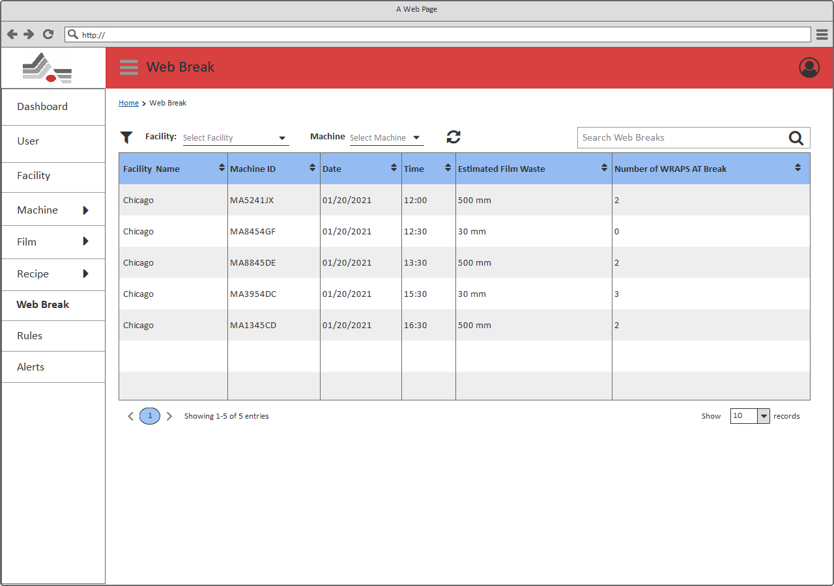

***[Web Break]***

Description

As shown in above page, User should be able to view the list of Web Break.

|  |  |  |  |  |
| --- | --- | --- | --- | --- |
| # | Field Name | Type | Mandatory (Y/N/NA) | Description |
| Page Header: User can view the title of the page (Web Break) and should be able to perform below mentioned actions. | | | | |
| 1 | Breadcrumb | Link | NA | User will be able to view the breadcrumb/navigation of current page. Using the breadcrumb, user will be able to navigate to the previous navigations.  Depending on the module from where the user is accessing this page, information in the breadcrumb will be generated dynamically. |
| 2 | Filter | Dropdown | NA | User will be able to select “Facility” and “Machine” from the dropdown options. It allows to select single option from the dropdown. After selecting any option filter activity should be initiated. It displays list of Web Breaks fall underneath selected facility and machine. |
| 3 | Search | Textbox | NA | User will be able to search any Web Break through keyword search available on the page.  **Note**:   1. Search should be performed on all the existing Web Breaks and if the result comprises multiple pages, then user should be able to access the next/previous result pages through pagination option. 2. User should get a message “***No results found***” when no record found as per the keyword. |
| View list of Web Breaks: Users should be able to view a list of all the existing Web Breaks with below mentioned details. If no Recipe is added into the system, page should display a message “*No Web Break exists*”. | | | | |
| 4 | Facility Name | Label | NA | User will be able to view facility name of the existing Web Break.  **Note**:   1. User should be able to sort the Facility Name alphabetically through the sort icon available with Facility Name title in the grid. |
| 5 | Machine ID | Label | NA | User will be able to view Machine ID of the existing Web Break.  **Note**:   1. User should be able to sort the Machine ID alphabetically through the sort icon available with Machine ID title in the grid. |
| 6 | Date | Label | NA | User will be able to view Date of the existing Web Break.  **Note**:   1. User should be able to sort the Date Oldest/Newest through the sort icon available with Date title in the grid. |
| 7 | Time | Label | NA | User will be able to view time of the existing Web Break.  **Note**:   1. User should be able to sort the time Oldest/Newest through the sort icon available with time title in the grid. |
| 8 | Estimated Film Waste | Label | NA | User will be able to view Estimated Film Waste of the existing Web Break.  **Note**:   1. User should be able to sort the width ascending/descending through the sort icon available with Estimated Film Waste title in the grid. |
| 9 | Number of WRAPS AT Break | Label | NA | User will be able to view Number of WRAPS AT Break of the existing Web Break.  **Note**:   1. User should be able to sort the WRAPS ascending/descending through the sort icon available with WRAPS title in the grid. |
| 10 | Pagination | Buttons | NA | User will be able to access the other Web Breaks through the pagination available on the page.  Clicking on the page numbers will navigate the User to that page which contains the web breaks. |
| 11 | Page Size | Dropdown | NA | User can also manage the number of items to be displayed into the list through a page size combo box with options10/25/50/100 items in a list.  **Note**: By default, only 10 Records will be displayed. |

## Alerts

It allows to view all alerts from this section. This page can be accessible, by clicking on “Alerts” menu from the left side navigation menu.

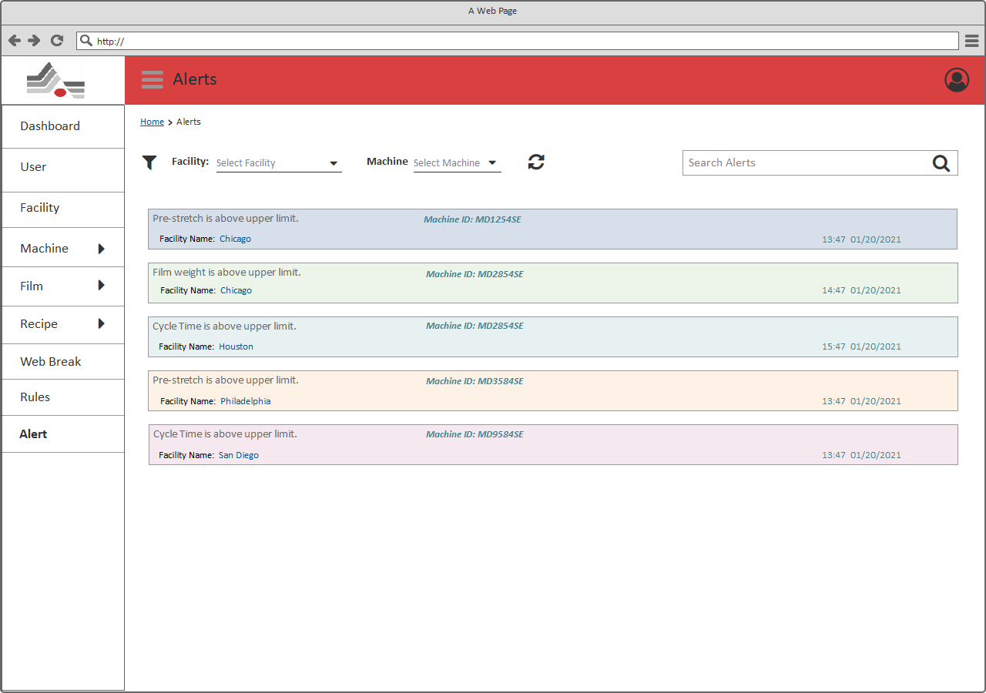

***[Alert]***

Description

As shown in above page, User should be able to view the list of alerts.

|  |  |  |  |  |
| --- | --- | --- | --- | --- |
| # | Field Name | Type | Mandatory (Y/N/NA) | Description |
| Page Header: User can view the title of the page (Alerts) and should be able to perform below mentioned actions. | | | | |
| 1 | Breadcrumb | Link | NA | User will be able to view the breadcrumb/navigation of current page. Using the breadcrumb, user will be able to navigate to the previous navigations.  Depending on the module from where the user is accessing this page, information in the breadcrumb will be generated dynamically. |
| 2 | Filter | Dropdown | NA | User will be able to select “Facility” and “Machine” from the dropdown options. It allows to select single option from the dropdown. After selecting any option filter activity should be initiated. It displays list of Alerts fall underneath selected facility and Machine. |
| 3 | Search | Textbox | NA | User will be able to search any Alert through keyword search available on the page.  **Note**:   1. Search should be performed on all the existing Alerts and if the result comprises multiple pages, then user should be able to access the next/previous result pages through pagination option. 2. User should get a message “***No results found***” when no record found as per the keyword. |
| View list of Alerts: Users should be able to view a list of all the existing Alerts with below mentioned details. If no Alert is added into the system, page should display a message “*No Alert exists*”. | | | | |
| 1 | Alert text | Label | NA | User will be able to view generated Alert. |
| 2 | Machine ID | Label | NA | User will be able to view Machine ID of the existing Alert. |
| 3 | Facility Name | Label | NA | User will be able to view facility name of the existing Alert. |
| 4 | Date & Time | Label | NA | User will be able to view Date & Time of the existing Alert. |

## My Profile

User will be able to view/edit profile from this section. This page can be accessible, by clicking on “Profile” menu from the profile menu pop-up view.

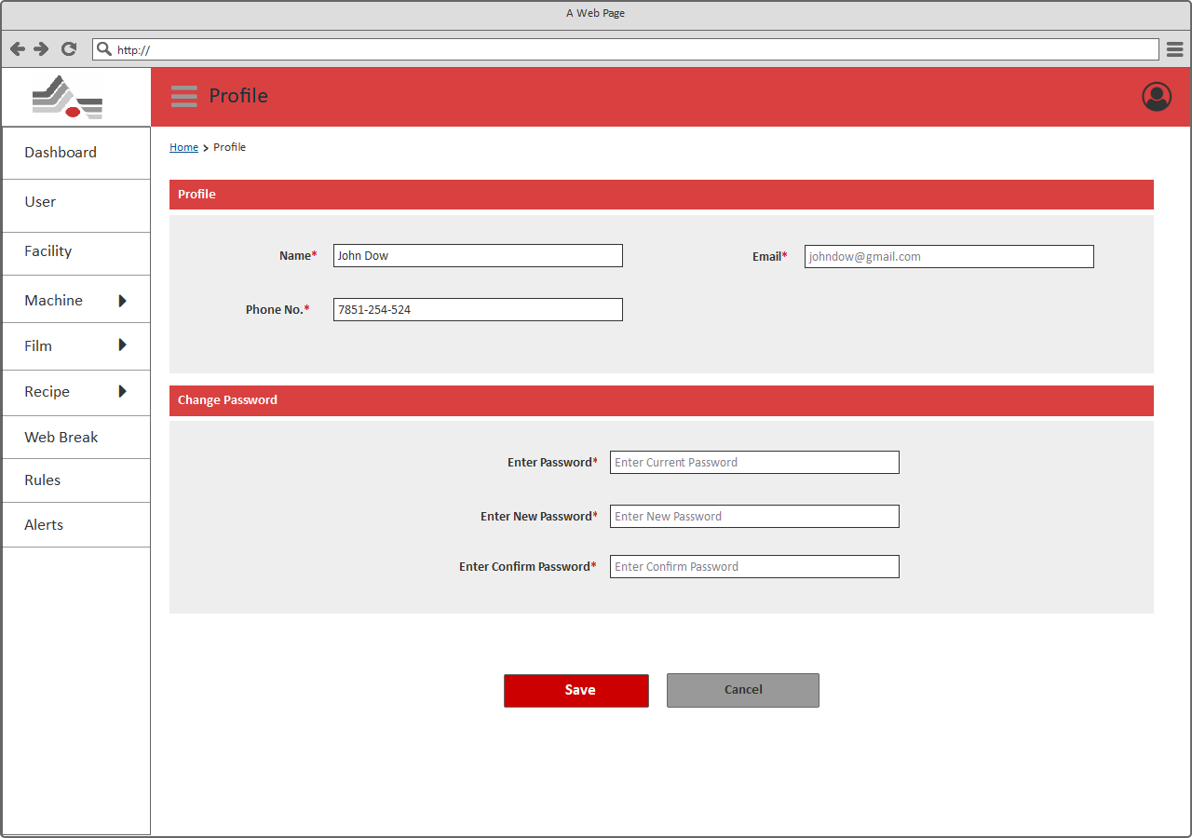

[Profile]

Description

|  |  |  |  |  |
| --- | --- | --- | --- | --- |
| # | Field Name | Field Type | Mandatory (Y/N/NA) | Comments |
| **Page Header**: User can view the title of the module (Profile) and should be able to perform below mentioned actions. | | | | |
| 1 | Breadcrumb | Link | NA | User should be able to view the breadcrumb/navigation of current page. Using the breadcrumb, user should be able to navigate to the previous navigations.  Depending on the module from where the user is accessing this page, information in the breadcrumb will be generated dynamically. |
| **View/ Update profile**: This page should allow user to view/update below mention details of the user profile. | | | | |
| 2 | Name | Textbox | Y  “Please enter name” | User should be able to view/update name of the user.  This field should contain prefilled value of name based on the logged in user. |
| 3 | Email | Label | NA | User should be able to view contact email of the user.  ***Notes:***   1. This field should be non-editable so user should not be able to update the email address. 2. This field should contain prefilled value of Email based on the selected User from User list page. |
| 4 | Contact No | Textbox | Y  “Please enter contact no” | User should be able to view/update contact no of the user.  This field should contain prefilled value of contact no based on the logged in user. |
| **Change Password**: This page should allow user to update below mention details. | | | | |
| 5 | Password | Textbox | Y  “Enter current password” | User should be able to enter password.  **Notes:**   1. This field should be masked.   User should get a message “**Invalid password**” if user enters invalid password. |
| 6 | New Password | Textbox | Y  “Enter new password” | User should be able to enter new password.  **Notes:**   1. This field should be masked.   The password should be a combination of alphabets, numbers and special characters. It should be minimum 8 characters long and contain at least 1 upper case character, 1 number and 1 special character. |
| 7 | Confirm Password | Textbox | Y  “Enter confirm password” | User should be able to enter confirm password.  **Notes:**   1. This field should be masked.   The values entered in New Password and Confirm New Password field should be same. In case they do not match then “**New password and Confirm passwords do not match**” message should be shown |
| 8 | Save | Button | NA | Clicking on this button, it should redirect user to verification page.  On successful validation, it should update the profile information. |
| 9 | Cancel | Button | NA | Clicking on this button should navigate the user to landing page without updating profile information in the system. |

## Verification

This page can be accessible, by clicking on “Save” button from the profile page. This page performs user authentication. Once user enters password for the account, system validates the password. If provided password is valid then profile details will be updated else it shows relevant error message.

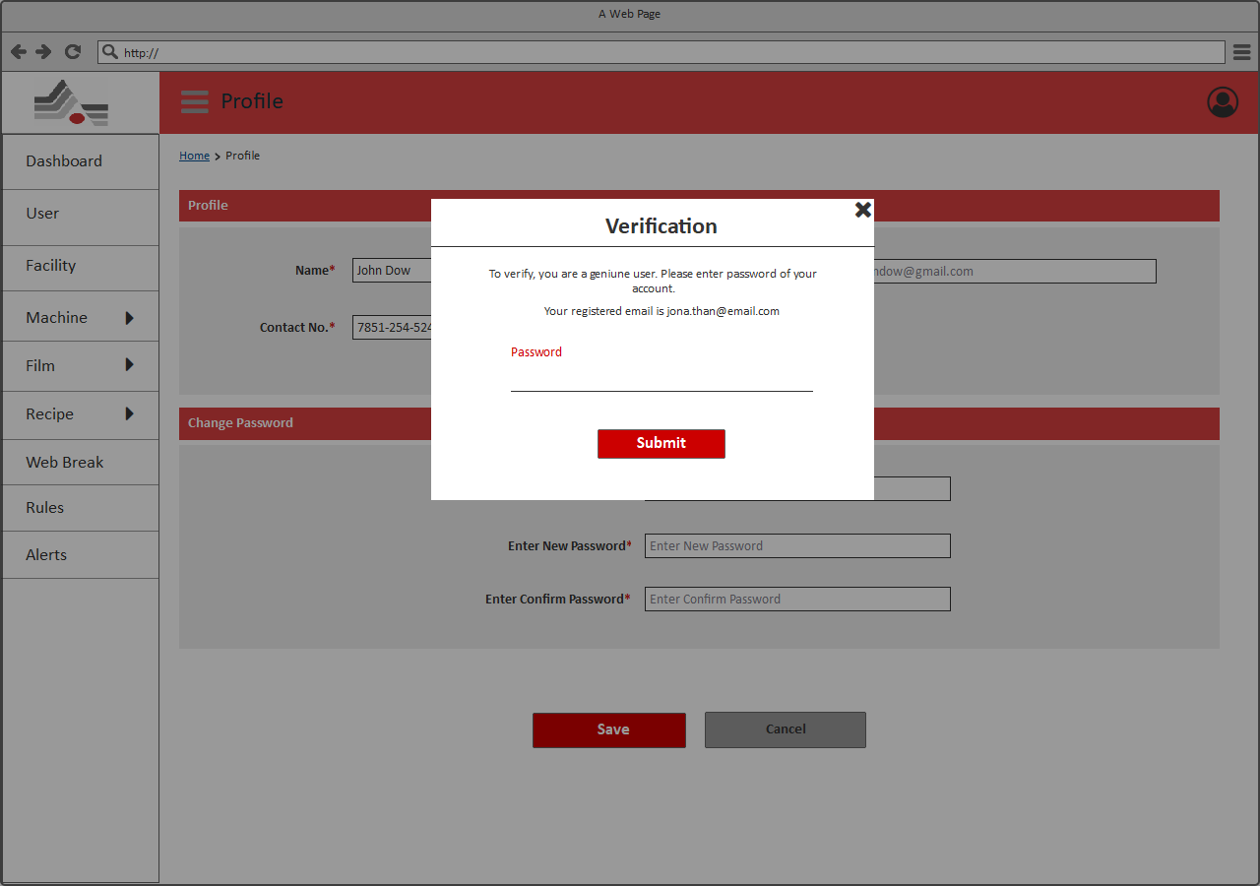

[Verification]